Ascension of the Lord

Entrance Hymn: Jesus Is Risen
1. Jesus is risen! Let us sing! Praise to the ever living King! Alleluia! Alleluia!
Praise him in song, ye Seraphim! Praise him with joy, ye Cherubim!
Alleluia! Alleluia! Alleluia! Alleluia! Alleluia!
2. On this most holy day of days, let us together sing his praise! Alleluia Alleluia!
Raise joyful voices to the sky! Sing out, ye heavens, in reply:
Alleluia! Alleluia! Alleluia! Alleluia! Alleluia!
3. To God the Father let us sing, To God the Son, our risen King! Alleluia Alleluia
And equally let us adore The holy Spirit ever more!
Alleluia! Alleluia! Alleluia! Alleluia! Alleluia!

Kyrie: Kýrie, eléison; Christé, eléison; Kýrie, eléison.

Gloria: Glória in excélsis Deo
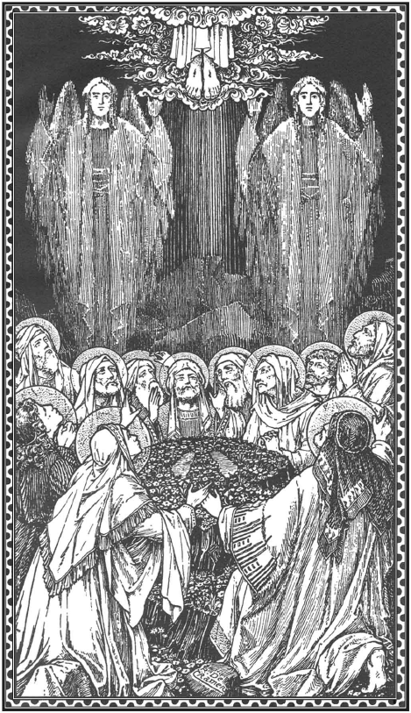
et in terra pax homínibus bonae voluntátis.
Laudámus te, benedícimus te, adorámus te, glorificámus te,
grátias ágimus tibi propter magnam glóriam tuam,
Dómine Deus, Rex cæléstis, Deus Pater omnípotens.
Dómine Fili Unigénite, Iesu Christe, Dómine Deus, Agnus Dei, Fílius Patris,
qui tollis peccáta mundi, miserére nobis;
qui tollis peccáta mundi, súscipe deprecatiónem nostram.
Qui sedes ad déxteram Patris, miserére nobis.
Quóniam tu solus Sanctus, tu solus Dóminus, tu solus Altíssimus, Iesu Christe,
cum Sancto Spíritu: in glória Dei Patris. Amen.

Responsorial Psalm: Psalm 47:2-3, 6-7, 8-9
R/. God mounts his throne to shuts of joy: a blare of trumpets for the Lord.

Offertory Hymn: Christ, the Lord, Is Risen Today
1. Christ, the Lord, is ris’n today, Alleluia! All on earth with angles say: Alleluia!
Raise your joys and triumphs high, Alleluia! Sing ye heav’ns and earth reply, Alleluia!
2. Lives again our glorious King; Alleluia! Where, O death, is now thy sting? Alleluia!
Once he died our souls to save, Alleluia! Where thy victory, O grave? Alleluia!
3. Love’s redeeming work is done, Alleluia! Fought the fight, the battle won. Alleluia!
Death in vain forbids him rise; Alleluia! Christ has open’d paradies. Alleluia!
4. Soar we now where Christ has led, Alleluia! Foll’wing our exalted head; Alleluia!
Made like him, like him we rise, Alleluia! Ours the cross, the grave, the skies. Alleluia!

Sanctus: Sanctus, Sanctus, Sanctus Dominus Deus Sabaoth.
Pleni sunt caeli et terra gloria tua. Hosanna in excelsis.
Benedictus qui venit in nomine Domini. Hosanna in excelsis.

Agnus Dei: Agnus Dei, qui tollis peccata mundi, miserere nobis.
Agnus Dei, qui tollis peccata mundi, miserere nobis.
Agnus Dei, qui tollis peccata mundi, dona nobis pacem.

Communion Hymn: TBA

Recessional Hymn: Alleluia! Alleluia! Let the Holy Anthem Rise
- Alleluia! Alleluia! Let the holy anthem rise,
And the choirs of heaven chant it In the temple of the skies;
Let the mountains skip with gladness, and the joyful valleys ring
With hosannas in the highest To our Savior and our King!
- Alleluia! Alleluia! Like the sun from out the wave,
He has risen up in triumph From the darkness of the grave.
He’s the splendor of the nations, He’s he lamp of endless day;
He’s the very Lord of glory Who is risen up today!
- Alleluia! Alleluia! Blessed Jesus, make us rise
From the life of this corruption To the life that never dies.
May your glory be our portion, When the days of time are past,
And the dead shall be awakened By the trumpet’s mighty blast!
Ascension of the Lord

Entrance Hymn: Jesus Is Risen
1. Jesus is risen! Let us sing! Praise to the ever living King! Alleluia! Alleluia!
Praise him in song, ye Seraphim! Praise him with joy, ye Cherubim!
Alleluia! Alleluia! Alleluia! Alleluia! Alleluia!
2. On this most holy day of days, let us together sing his praise! Alleluia Alleluia!
Raise joyful voices to the sky! Sing out, ye heavens, in reply:
Alleluia! Alleluia! Alleluia! Alleluia! Alleluia!
3. To God the Father let us sing, To God the Son, our risen King! Alleluia Alleluia
And equally let us adore The holy Spirit ever more!
Alleluia! Alleluia! Alleluia! Alleluia! Alleluia!

Kyrie: Kýrie, eléison; Christé, eléison; Kýrie, eléison.

Gloria: Glória in excélsis Deo
et in terra pax homínibus bonae voluntátis.
Laudámus te, benedícimus te, adorámus te, glorificámus te,
grátias ágimus tibi propter magnam glóriam tuam,
Dómine Deus, Rex cæléstis, Deus Pater omnípotens.
Dómine Fili Unigénite, Iesu Christe, Dómine Deus, Agnus Dei, Fílius Patris,
qui tollis peccáta mundi, miserére nobis;
qui tollis peccáta mundi, súscipe deprecatiónem nostram.
Qui sedes ad déxteram Patris, miserére nobis.
Quóniam tu solus Sanctus, tu solus Dóminus, tu solus Altíssimus, Iesu Christe,
cum Sancto Spíritu: in glória Dei Patris. Amen.

Responsorial Psalm: Psalm 47:2-3, 6-7, 8-9
R/. God mounts his throne to shuts of joy: a blare of trumpets for the Lord.

Offertory Hymn: Christ, the Lord, Is Risen Today
1. Christ, the Lord, is ris’n today, Alleluia! All on earth with angles say: Alleluia!
Raise your joys and triumphs high, Alleluia! Sing ye heav’ns and earth reply, Alleluia!
2. Lives again our glorious King; Alleluia! Where, O death, is now thy sting? Alleluia!
Once he died our souls to save, Alleluia! Where thy victory, O grave? Alleluia!
3. Love’s redeeming work is done, Alleluia! Fought the fight, the battle won. Alleluia!
Death in vain forbids him rise; Alleluia! Christ has open’d paradies. Alleluia!
4. Soar we now where Christ has led, Alleluia! Foll’wing our exalted head; Alleluia!
Made like him, like him we rise, Alleluia! Ours the cross, the grave, the skies. Alleluia!

Sanctus: Sanctus, Sanctus, Sanctus Dominus Deus Sabaoth.
Pleni sunt caeli et terra gloria tua. Hosanna in excelsis.
Benedictus qui venit in nomine Domini. Hosanna in excelsis.

Agnus Dei: Agnus Dei, qui tollis peccata mundi, miserere nobis.
Agnus Dei, qui tollis peccata mundi, miserere nobis.
Agnus Dei, qui tollis peccata mundi, dona nobis pacem.

Communion Hymn: TBA

Recessional Hymn: Alleluia! Alleluia! Let the Holy Anthem Rise
- Alleluia! Alleluia! Let the holy anthem rise,
And the choirs of heaven chant it In the temple of the skies;
Let the mountains skip with gladness, and the joyful valleys ring
With hosannas in the highest To our Savior and our King!
- Alleluia! Alleluia! Like the sun from out the wave,
He has risen up in triumph From the darkness of the grave.
He’s the splendor of the nations, He’s he lamp of endless day;
He’s the very Lord of glory Who is risen up today!
- Alleluia! Alleluia! Blessed Jesus, make us rise
From the life of this corruption To the life that never dies.
May your glory be our portion, When the days of time are past,
And the dead shall be awakened By the trumpet’s mighty blast!

