Palm Sunday

Mass of the Lord’s Passion

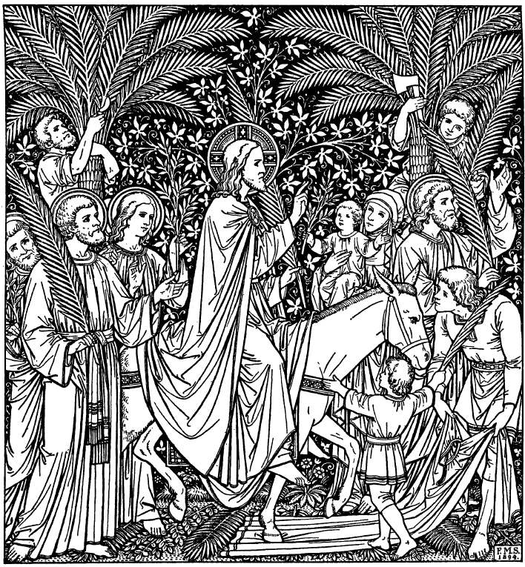

Our Lady of Mount Carmel Church

Newark, New Jersey
Sunday: 8:30am Mass only (All other masses begin on next page.)

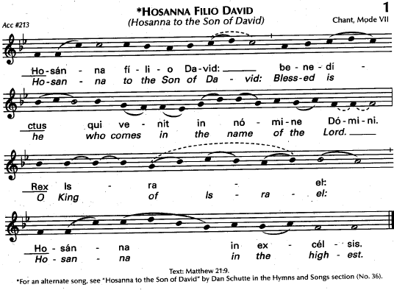

Blessing of Palms… (Please refer to Today’s Missal)

Gospel Reading: Luke 19:28-40 (Please refer to Today’s Missal)

Entrance Procession: “The Palms” by Jean-Baptiste Faure, Arr. Dudley Buck

1. “O’er all the way green palms and blossoms gay
Are strewn this day in festal preparation.
Where Jesus comes to wipe our tears away,
Even now the throngs to welcome Him prepare;

R/. Join all and sing, His name declare,
Let every voice resound with acclamation:
Hosanna! Praise to the Lord! Bless Him who cometh to bring us salvation!

2. His word goes forth, and people by its might
Once more regain freedom from degradation.
Humanity doth give to each his right,
While those in darkness are restored to light. R/.

3. Sing and rejoice, O blest Jerusalem,
Of all thy sons sing the emancipation.
Through boundless love the Christ of Bethlehem
Brings faith and hope to thee forevermore. R/.

Kyrie:* “A People’s Mass” – Dom Gregory Murray
*(Omit at 8:30am Mass)
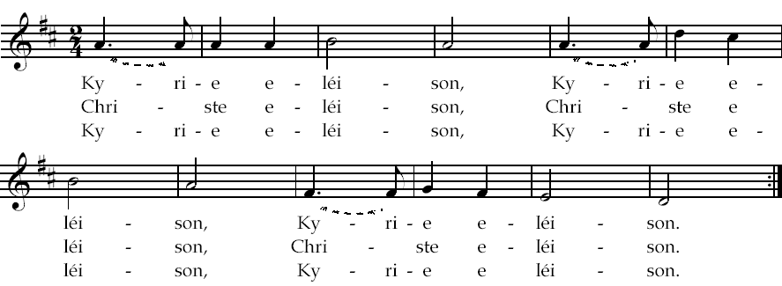

Opening Prayer: (Please refer to Today’s Missal)
Liturgy of the Word...
(Please refer to Today’s Missal)

First Reading : Isaiah 50:4-7
Responsorial Psalm: “My God, My God, Why have you abandoned me?
Second Reading: Philippians 2:6-11
Gospel Acclamation: “Praise to you, Lord Jesus Christ,
King of endless glory.”
Gospel Reading: Luke 22:14-23:56
Homily...

Liturgy of the Eucharist...

Offertory Anthem: “The Holy City” - words by Weatherly, music by Stephen Adams, Edited by James Allan Dash.

Last night as I lay sleeping, There came a dream so fair, I stood in old Jerusalem beside the temple there. I heard the children singing, And ever as they sang, Me thought the voice of Angels from Heav’n in answer rang, Me thought the voice of Angels from Heav’n in answer rang;
Jerusalem, Jerusalem, Lift up your hearts and sing, Hosanna in the highest, Hosanna to your King!

And then me thought my dream was changed, the streets no longer rang. Hushed were the glad Hosannas the little children sang. The Sun grew dark with mystery, The morn was cold and chill, As the shadow of a cross rose upon a lonely hill as the shadow of a cross rose upon a lonely hill,
Jerusalem, Jerusalem, Hark how the angels sing. Hosanna in the highest, Hosanna to your King!

And once again the scene was changed, New earth there seemed to be, I saw the Holy City beside the tide-less sea, The light of God was on it’s streets, the gates were open wide, and all who would might enter, and no one was denied. No need for moon or stars by night or sun to shine by day. It was the new Jerusalem that would not pass away. It was the new Jerusalem that would not pass away.
Jerusalem, Jerusalem, Sing for the night is o’er. Hosanna in the highest, Hosanna forever more, Hosanna in the highest! Hosanna forever more.
Sanctus – Benedictus: “A People’s Mass” – Dom Gregory Murray
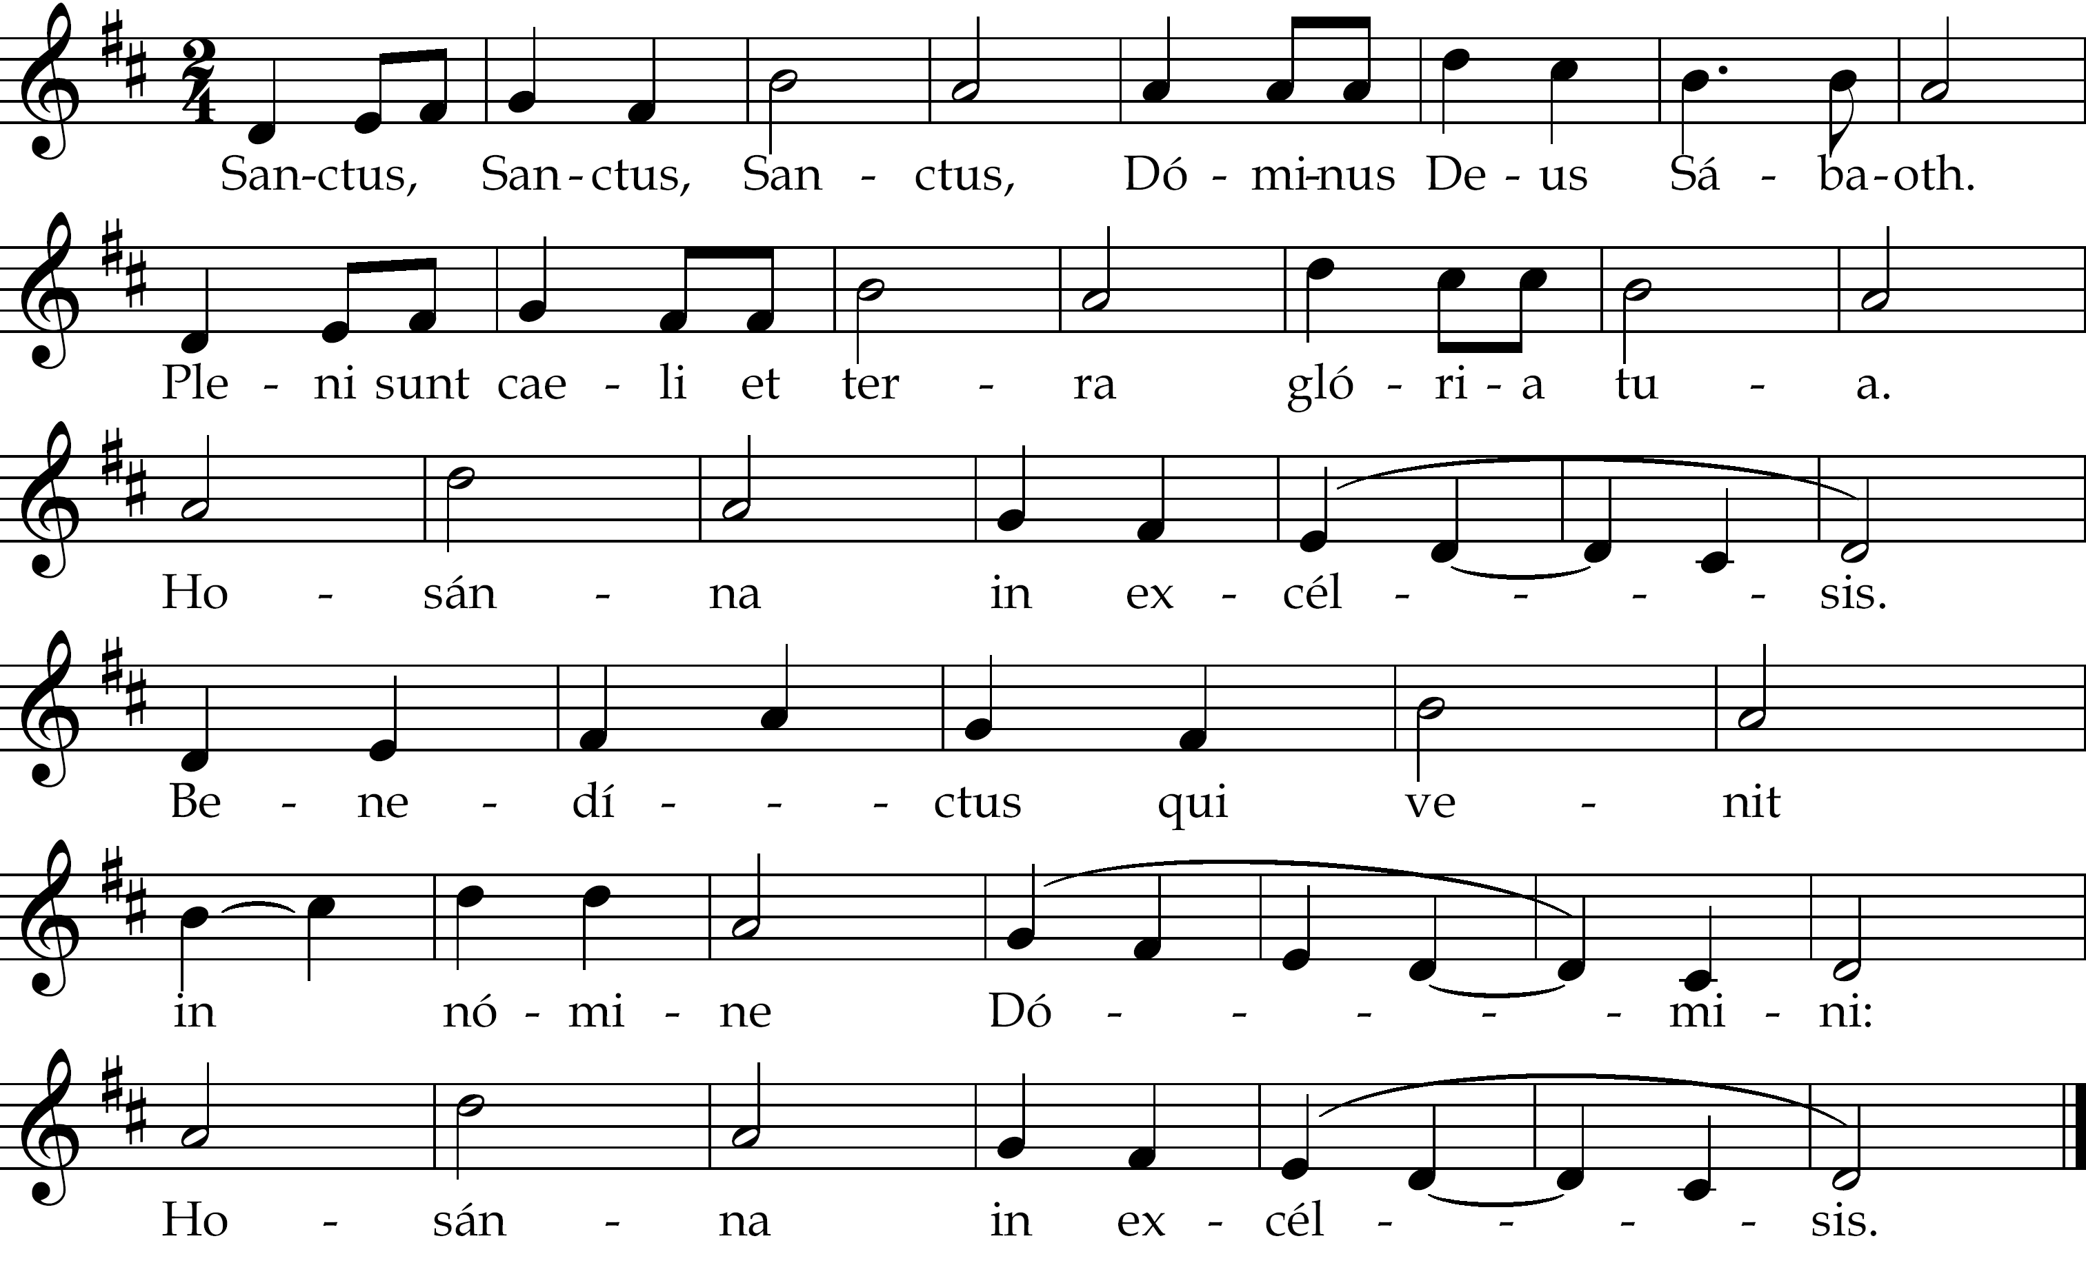
Memorial Acclamation and Amen: – Marty Haugen.
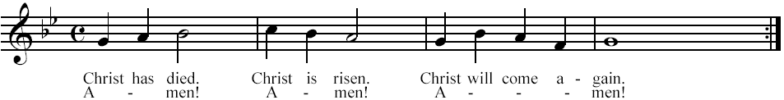
Agnus Dei: “A People’s Mass” – Dom Gregory Murray
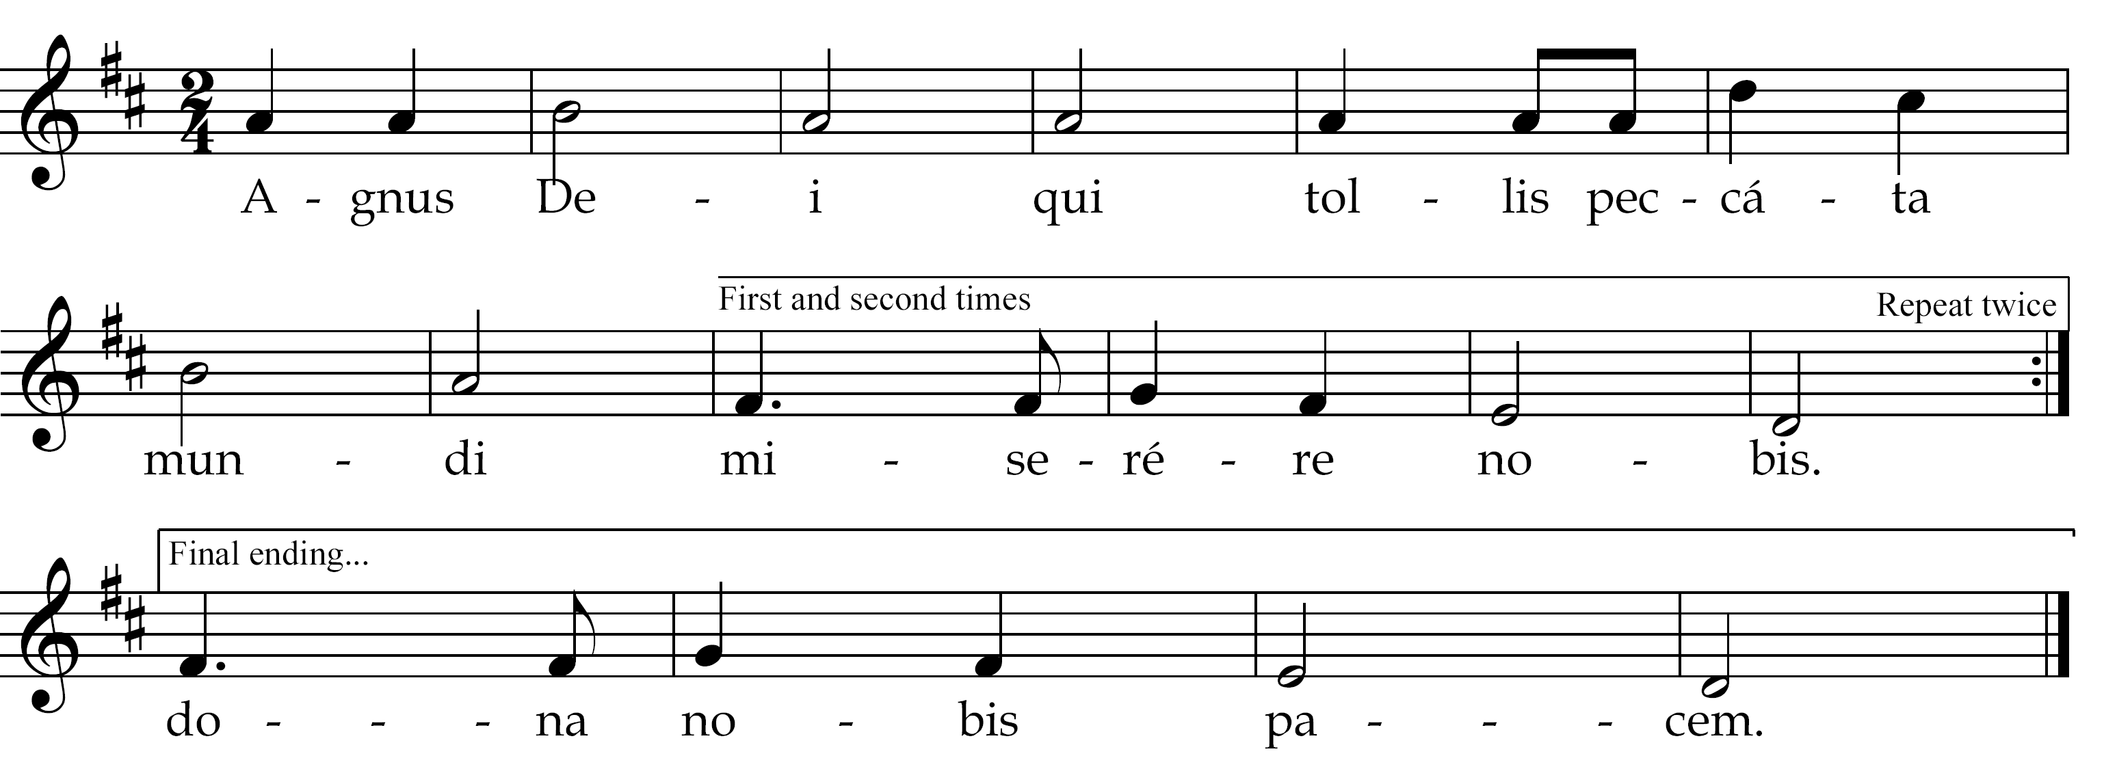
Communion Hymn: Soul of my Saviour
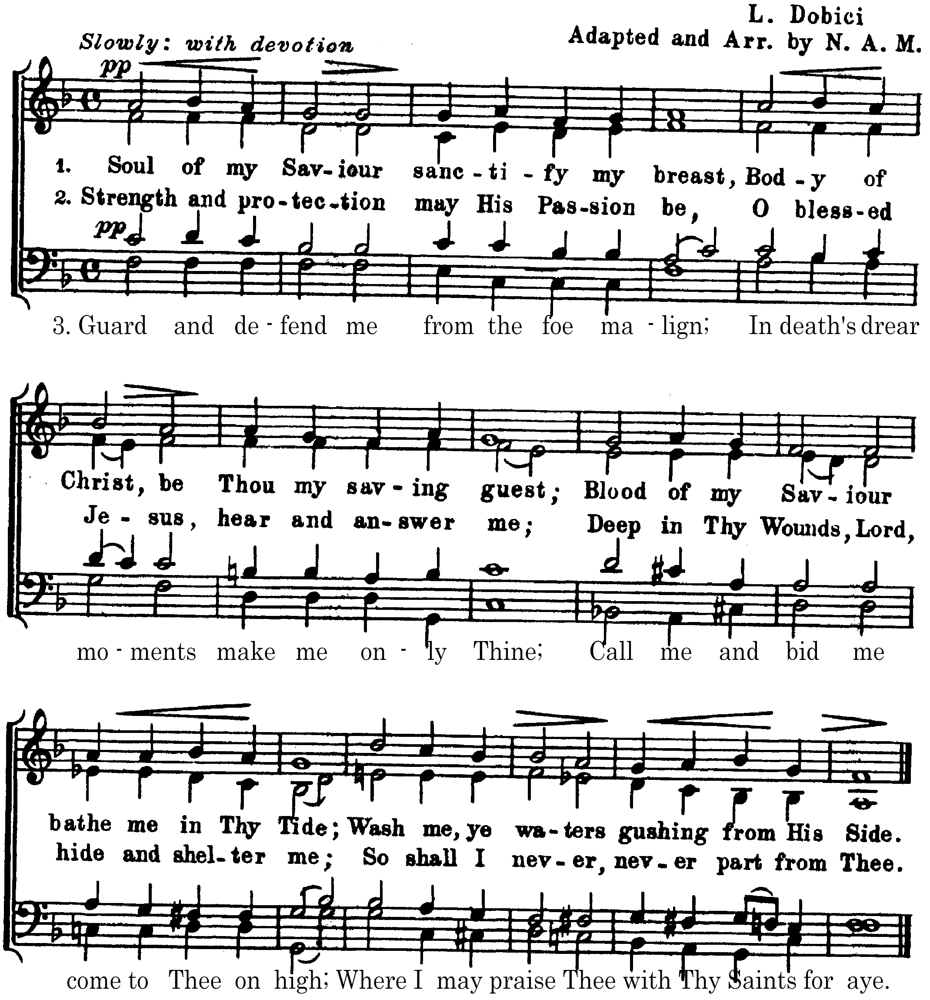

Communion Meditation: Adoramus Te ~ Giovanni da Palestrina
Adoramus te Christe: et benedicimus tibi; Quia per sanctam crucem tuam redemisti mundum; qui passus es pro nobis; Domine, Domine, miserere nobis. | “We adore thee O Christ, and we bless thee; because by thy Holy Cross, Thou hast redeemed the world. Thou wert given up for us; Lord, Lord, have mercy on us.”
Recessional Hymn: To Jesus Christ, our Sovereign King
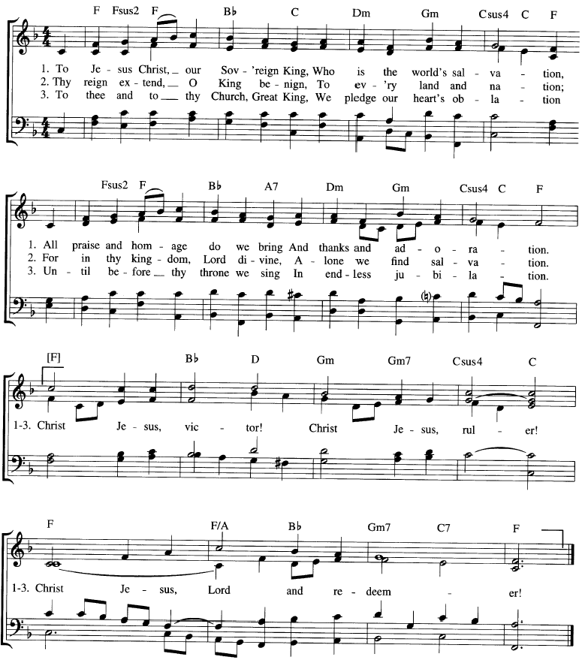

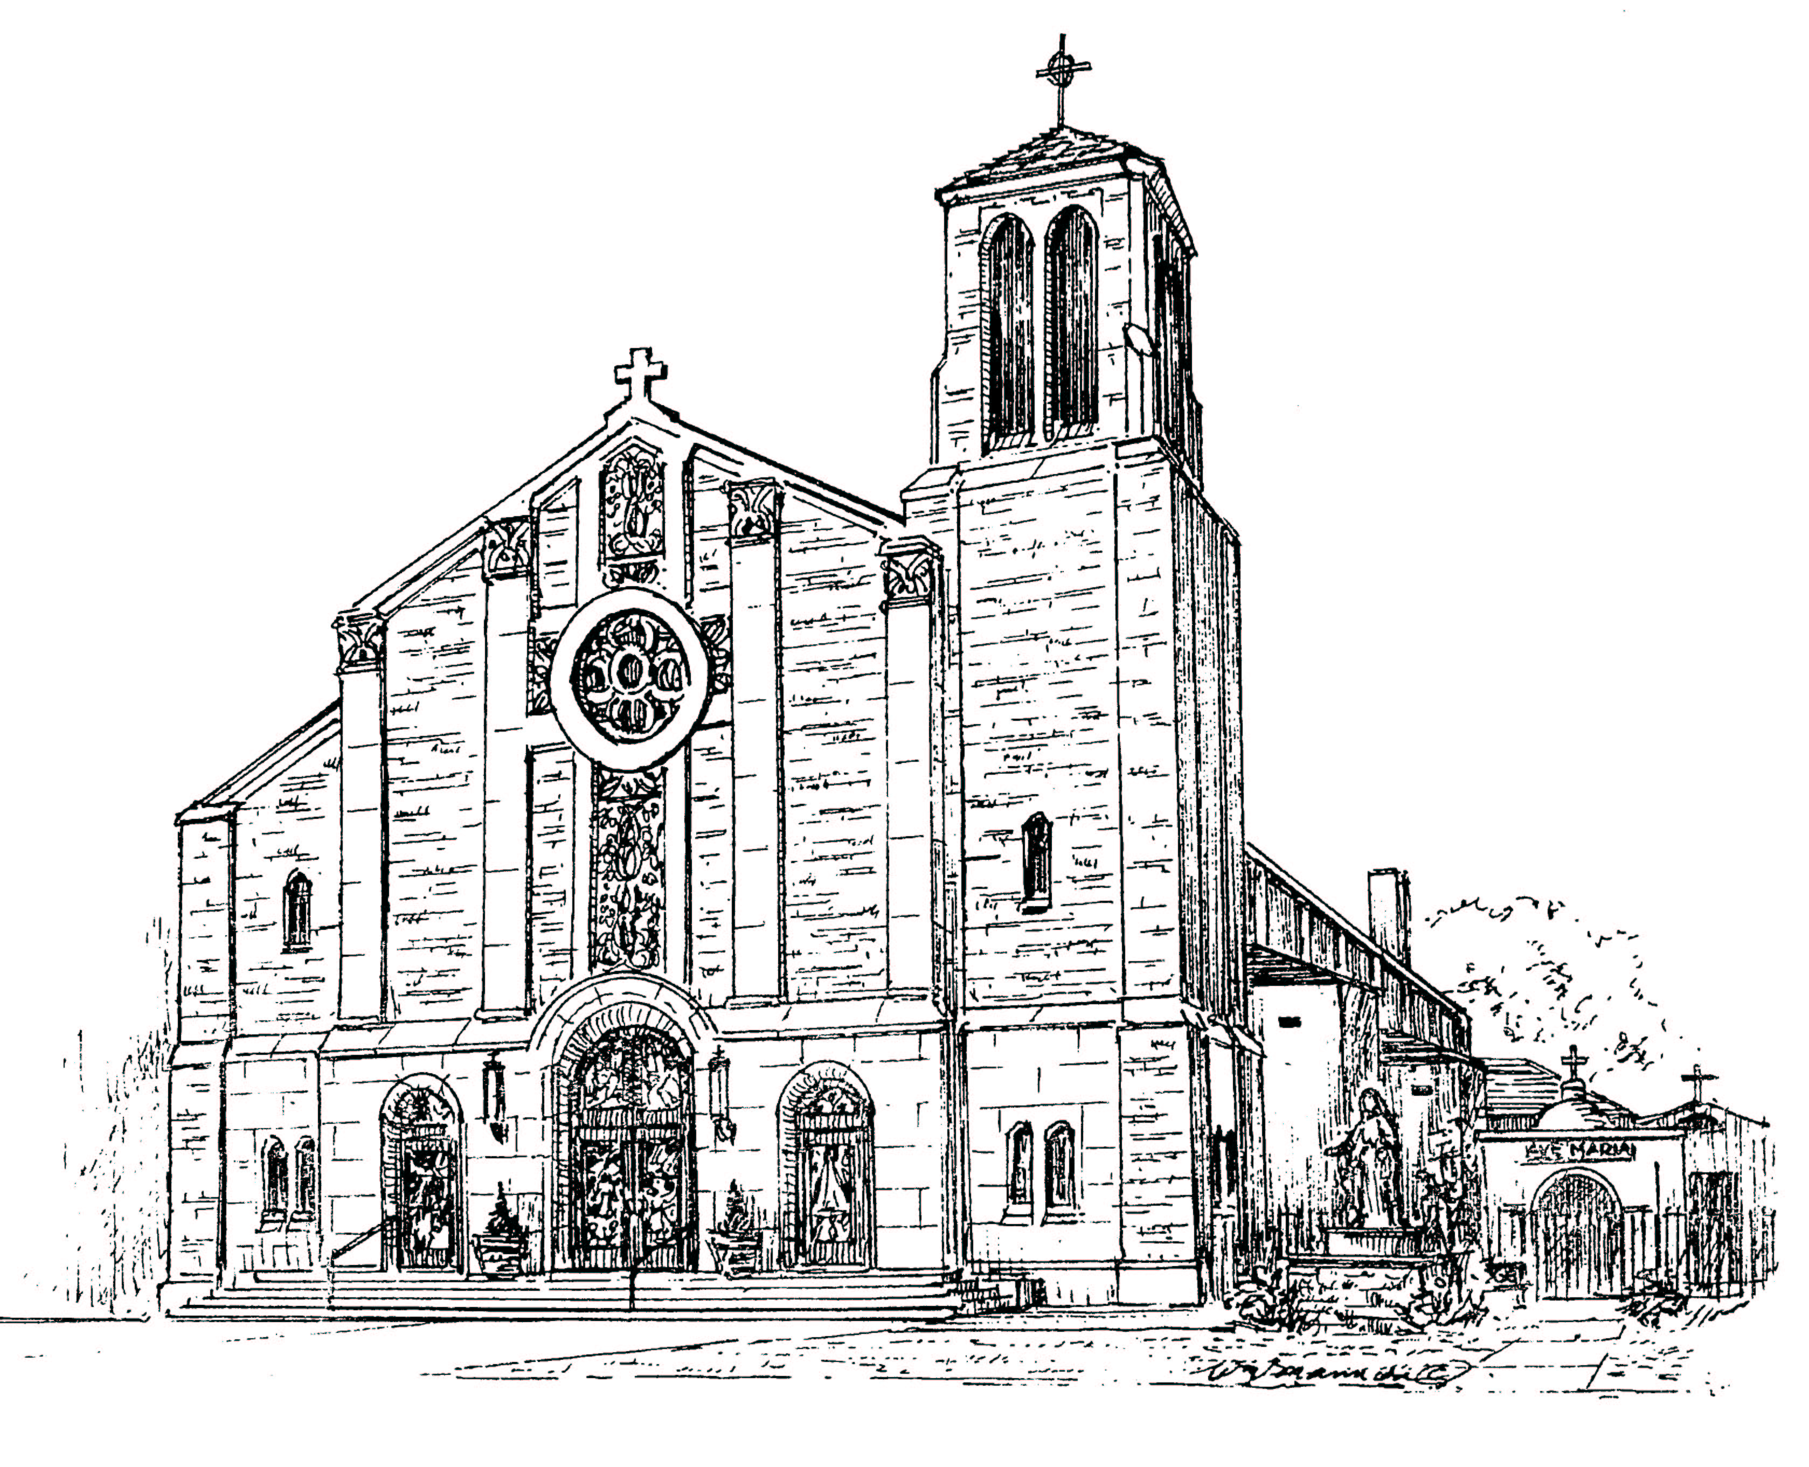

Our Lady of Mount Carmel Church
259 Oliver Street ~ Newark, New Jersey 07105
(973) 589-2090 mtcarmel259@optonline.net
http://ourladyofmtcarmelnewark.e-paluch.com

Rev. Msgr. Joseph F. Ambrosio, M. A., Pastor
Rev. Anthony Forte, Parochial Vicar, Chaplain of Newark Fire Department
Rev. Michael Barone, In residence
Rev. Nicholas Figurelli, Weekend Assistant
Mr. John M. Thomas, Director of Music

This program is property of Our Lady of Mt. Carmel Church, Newark NJ.
Please do not remove from church.
MMX Anno Domini.

