Holy Thursday
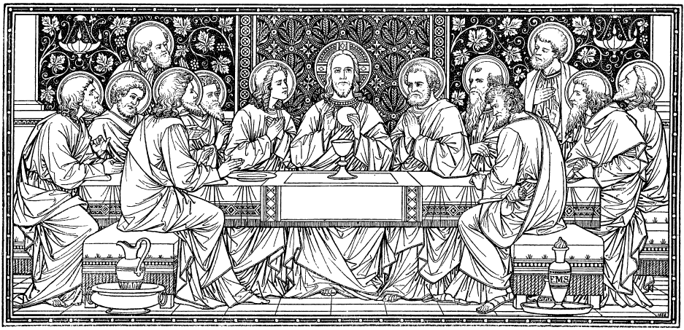
Evening Mass of the Lord’s Supper
══════════════════════════════════════════════════════

~ SALUTATIO ~  V. In nómine Patris, èt Filii, et Spiritus Sancti.  Populus respondet: Amen.  V. Grátia Dómini nostri Iesu Christi, et cáritas Dei, et communicátio Sancti Spiritus sit cum omnibus vobis.  Populus respondet: Et cum spiritu tuo. | ~ GREETING ~  V. In the name of the Father, and of the Son, and of the Holy Spirit. The people answer: Amen.  V. The grace of our Lord Jesus Christ and the love of God and the fellowship of the Holy Spirit be with you all.  The people answer: And also with you.

~ ACTUS PÆNITENTIALIS ~  Fratres, agnoscámus peccáta nostra, ut apti simus ad sacra mystéria celebránda. Confiteor Deo omnipotenti et vobis, fratres, quia peccávi nimis cogitatióne, verbo, ópere et omissióne: | ~ PENITENTIAL RITE ~  As we prepare to celebrate the mystery of Christ’s love, let us acknowledge our failures and ask the Lord for pardon and strength. I confess to almighty God, and to you, my brothers and sisters, I have sinned exceedingly in thought, word, and deed
They strike their breast:
mea culpa, mea culpa, mea maxima culpa.  Ideo precor beátam Mariam semper Virginem, omnes Angelos et Sanctos, et vos, fratres, oráre pro me ad Dóminum Deum nostrum.  Misereátur nostri omnipotens Deus et, dimissis peccátis nostris, perdúcat nos ad vitam ætérnam.  Populus respondet: Amen | through my fault, through my most grievous fault. Therefore I beseech the blessed Mary, ever Virgin, all the angels and saints, and you, my brothers and sisters, to pray for me to the Lord our God.  May almighty God have mercy on us, forgive us our sins, and bring us to everlasting life.  The people answer: Amen.
Kyrie Eleison, Kyrie Eleison, Kyrie Eleison.  Christe Eleison, Christe Eleison, Christe Eleison.  Kyrie Eleison, Kyrie Eleison, Kyrie Eleison. | Lord, have mercy. Lord, have mercy. Lord, have mercy.  Christ, have mercy. Christ, have mercy. Christ, have mercy.  Lord, have mercy. Lord, have mercy. Lord, have mercy.
V. Gloria in Excelsis Deo R/. et in terra pax homínibus bonae voluntátis. Laudámus te, benedícimus te, adorámus te, glorificámus te, grátias ágimus tibi propter magnam glóriam tuam, Dómine Deus, Rex cæléstis, Deus Pater omnípotens. Dómine Fili Unigénite, Iesu Christe, Dómine Deus, Agnus Dei, Fílius Patris, qui tollis peccáta mundi, miserére nobis; qui tollis peccáta mundi, súscipe deprecatiónem nostram. Qui sedes ad déxteram Patris, miserére nobis. Quóniam tu solus Sanctus, tu solus Dóminus, tu solus Altíssimus, Iesu Christe, cum Sancto Spíritu: in glória Dei Patris. Amen. |  | Glory to God in the highest, and on earth peace to people of good will. We praise you, we bless you, we adore you, we glorify you, we give you thanks for your great glory, Lord God, heavenly King, O God, almighty Father. Lord Jesus Christ, Only Begotten Son, Lord God, Lamb of God, Son of the Father, you take away the sins of the world, have mercy on us; you take away the sins of the world, receive our prayer. you are seated at the right hand of the Father, have mercy on us. For you alone are the Holy One, you alone are the Lord, you alone are the Most High, Jesus Christ, with the Holy Spirit, in the glory of God the Father. Amen.

~ COLLECTA ~  Sacratissimam, Deus, frequentantibus Cenam, in qua Unigénitus tuus, morti se traditúrus, novum in sǽcula sacrificium dilectionisque suæ convivium Ecclésiæ commendávit,da nobis, quǽsumus, ut ex tanto mystério plenitudinem caritátis hauriámus et vitæ.  Per Dóminum. | ~ OPENING PRAYER ~  God our Father, we are gathered here to share in the supper which your only Son left to his Church to reveal his love. He gave it to us when he was about to die and commanded us to celebrate it as the new and eternal sacrifice. We pray that in this Eucharist we may find the fullness of love and life. Grant this through our Lord Jesus Christ, your Son, who lives and reigns with you and the Holy Spirit, one God, for ever and ever.

~ LITURGIA VERBI ~  Primam Lectionem: Exodus 12:1-8, 11-14 (39ABC)  Ad finem, lector subdit: Verbum Dómini.  Omnes acclamant: Deo Grátias.  Psalmum Responsorius:Psalm 116:12-13, 15-16bc, 17-18  Secunda Lectionem: 1 Corinthians 11:23-26  Ad finem, lector subdit: Verbum Domini.  Omnes acclamant: Deo Grátias.  V. Dominus Vobíscum  R. Et cum spíritu tuo.  V. Léctio sancti Evangélii secúndum Ioánnem.,  R. Glória tibi, Dómini.  Evangelium: John 13:1-15  Finito Evangelio: Verbum Dómini.  Omnibus acclamantibus: Laus tibi, Christe.  Homilia... | ~ LITURGY OF THE WORD ~  First Reading: Exodus 12:1-8, 11-14 (39ABC)  Lector concludes: The Word of the Lord.  All acclaim: Thanks be to God.  Responsorial Psalm: Psalm 116:12-13, 15-16bc, 17-18  Second Reading: 1 Corinthians 11:23-26  Lector concludes: The Word of the Lord.  All acclaim: Thanks be to God.  V. The Lord be with you.  R. And also with you.  V. A reading from the holy Gospel according to John.  R. Glory to you, Lord.  Gospel Reading: John 13:1-15  After the Gospel: The Gospel of the Lord.  All acclaim: Praise to you, Lord Jesus Christ.  Homily...

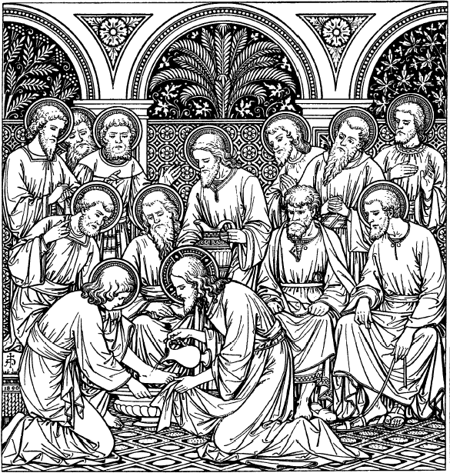  ~ LAVATIO PEDI ~ | ~ WASHING OF FEET ~

The washing of the feet takes place after the homily. The celebrant girds himself with a cloth, and assisted by his ministers, begins the washing of the feet of twelve men chosen for the ceremony.
While the subdeacon holds the right foot of each of those whose feet are to be washed, the celebrant, kneeling before him, washes the foot and wipes it, the deacon handing him a towel for the wiping.

~ LITURGIA EUCHARISTICA ~ | ~ LITURGY OF THE EUCHARIST ~
Benedictus es, Dómine, Deus univérsi, quia de tua largitáte accépimus panem,quem tibi offérimus,  fructum terræ et óperis mánuum hóminum: ex quo nobis fiet panis vitæ.  Benedíctus Deus in sæcula.  Per huius aquæ et vini mystérium eius efficiámur divini tátis consórtes, qui humanitátis nostræ fieri dignatus est párticeps. Benedíctus es, Dómine, Deus univérsi, quia de tua largitáte accépimus vinum, quod tibi offérimus, fructum vitis et óperis mánuum hóminum, ex quo nobis fiet potus spiritális.  Benedíctus Deus in sæcula.  In spíritu humilitátis et in ánimo contríto suscipiámur a te, Dómine; et sic fiat sacrifícium nostrum in conspéctu tuo hódie, ut pláceat tibi, Dómine Deus. Lava me, Dómine, ab iniquitáte mea, et a peccáto meo munda me. Oráte, fratres: ut meum ac vestrum sacrifícium acceptábile fiat apud Deum Patrem omnipoténtem.  Suscípiat Dóminus sacrifícium de mánibus tuis  ad laudem et glóriam nóminis sui, ad utilitátem quoque nostram totiúsque Ecclésiæ suaæ sanctæ.  Super oblata  Concéde nobis, quǽsumus, Dómine, hæc digne frequentáre mystéria, quia, quóties huius hóstiæ commemorátio celebrátur, opus nostræ redemptiónis exercétur. Per Christum. | Blessed are you, Lord, God of all creation. Through your goodness we have this bread to offer, which earth has given and human hands have made. It will become for us the bread of life.  Blessed be God for ever.  By the mystery of this water and wine may we come to in the divinity of Christ, who humbled himself to share in our humanity. Blessed are you, Lord, God of all creation. Through your goodness we have this wine to offer, fruit of the vine and work of human hands. It will become our spiritual drink.  Blessed be God for ever.  Lord God, we ask you to receive us and be pleased with the sacrifice we offer you with humble and contrite hearts. Lord, wash away my iniquity; cleanse me from my sin. Pray, brethren: that our sacrifice may be acceptable to God, the almighty Father.  May the Lord accept the sacrifice at your hands  for the praise and glory of his name,  for our good, and the good of all his Church.  Prayer over the gifts  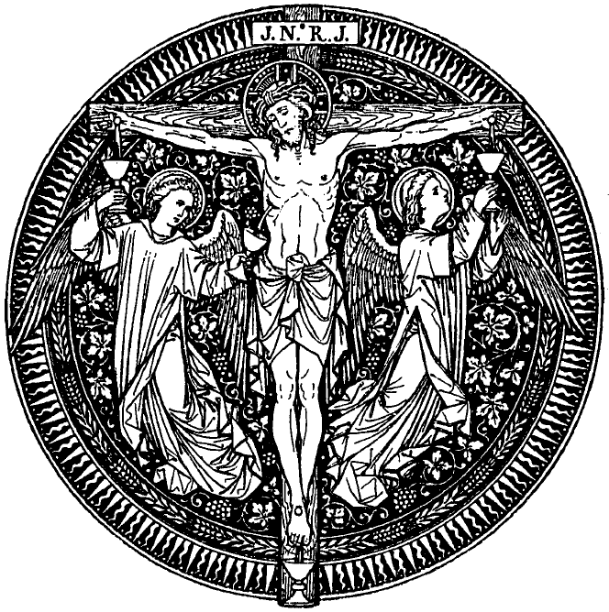  Lord, make us worthy to celebrate these mysteries. Each time we offer this memorial sacrifice the work of our redemption is accomplished. We ask this in the name of Jesus the Lord.

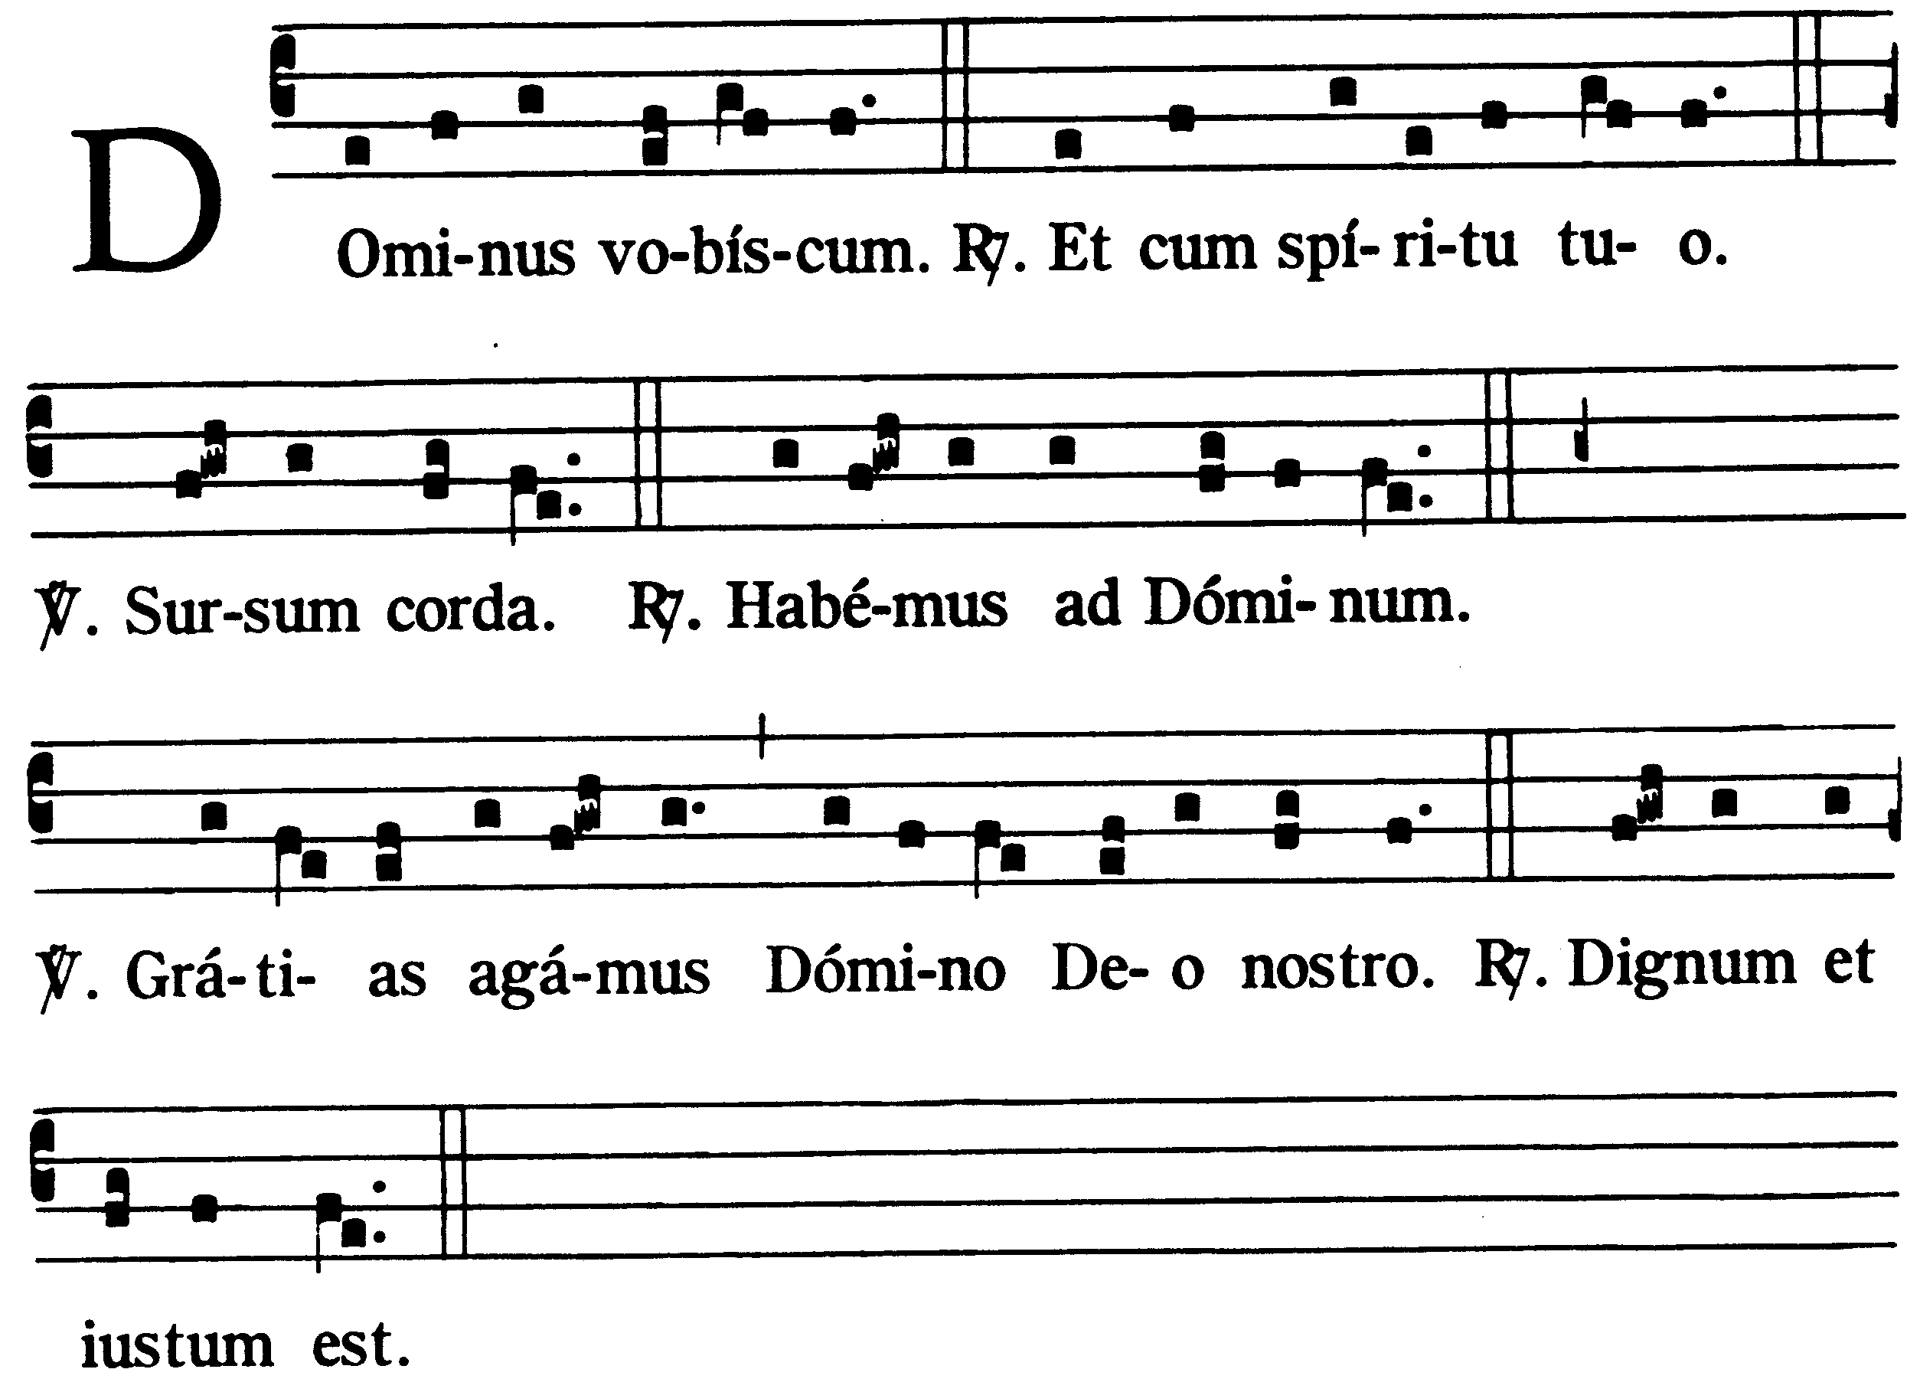  Prex Eucharistica: | Eucharistic Prayer:  Priest: The Lord be with you,  People: And also with you.  Priest: Lift up your hearts.  People: We lift them up to the Lord.  Priest: Let us give thanks to the Lord our God.  People: It is right to give him thanks and praise.
~ Præefatio de Ss.ma Eucharistia, I. ~  Vere dignum et iustum est, æquum et salutáre, nos tibi semper et ubíque grátias ágere: Dómine, sancte Pater, omnipotens ætérne Deus: per Christum Dóminum nostrum. Qui, verus æternúsque Sacérdos, formam sacrifícii perénnis instítuens, hóstiam tibi se primus óbtulit salutárem, et nos, in sui memóriam, præcépit offérre. Cuius carnem pro nobis immolátam dum súmimus, roborámur, et fusum pro nobis sánguinem dum potámus, ablúimur. Et ídeo cum Angelis et Archángelis, cum Thronis et Dominatiónibus, cumque omni milítia cæléstis exércitus, hymnum glóriæ tuæ cánimus, sine fine dicéntes: 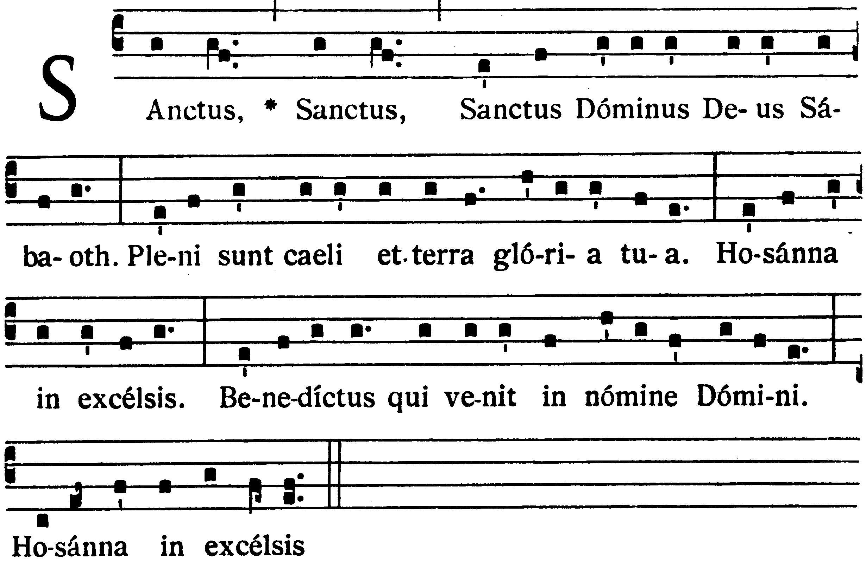 |  | ~ Preface of the Holy Eucharist, I. ~  Father, all-powerful and ever-living God, we do well always and everywhere to give you thanks through Jesus Christ our Lord. He is the true and eternal priest who established this unending sacrifice. He offered himself as a victim for our deliverance and taught us to make ‘this offering in his memory. As we eat this body which he gave for us, we grow in strength. As we drink his blood which he poured out for tis, we are washed clean. Now, with angels and archangels, and the whole company of heaven, we sing the unending hymn of your praise:  Holy, holy, holy Lord, God of power and might,  Heaven and earth are full of your glory.  Hosanna in the highest.  Blessed is he who comes in the name of the Lord.    Hosanna in the highest.
~ PREX EUCHARISTICA I ~  (Seu Canon Romanus)  Te igítur, clementíssime Pater, per Iesum Christum, Fílium tuum, Dóminum nostrum, súpplices rogámus ac pétimus, uti accépta hábeas et benedícas  hæc dona, hæc múnera, hæc sancta sacrifícia illibáta in primis, quæ tibi offérimus pro Ecclésia tua sancta cathólica: quam pacificáre, custodíre, adunáre et régere dignéris toto orbe terrárum: una cum fámulo tuo Papa nostro N. et Antístite nostro N.* et omnibus orthodóxis atque cathólicæ et apostólicæ fidei cultóribus. |  | ~ EUCHARISTIC PRAYER I ~  (Roman Canon)  We come to you, Father, with praise and thanksgiving, through Jesus Christ your Son. Through him we ask you to accept and bless these gifts we offer you in sacrifice. We offer them for your holy catholic Church, watch over it, Lord, and guide it; grant it peace and unity throughout the world, We offer them for N. our Pope, for N. our bishop N. and for all who hold and teach the catholic faith that comes to us from the apostles.
~ Commemoratio Pro Vivis ~  Meménto, Dómine, famulórum farnularúmque tuárurn N. et N. et ómnium circumstántium, quorum tibi fidcs cógnita est et nota dcvótio, pro quibus tibi offérimus: vel qui tibi ófferunt hoc sacrificium laudis, pro se suísque ómnibus: pro redemptióne animárum suárum, pro spe salútis et incolumitátis suæ: tibíque reddunt vota sua ætérno Deo, vivo et vero.  Communicántes, et diem sacratíssimum celebrántes quo Dóminus noster Iesus Christus pro nobis est tráditus, sed et memóriam venerántes, in primis gloriósæ semper Vírginis Mariæ, Genetricis eiúsdem Dei et Dómini nostri Iesu Christi: † sed et beáti Ioseph, eiúsdem Vírginis Sponsi, et beatórum Apostolórum ac Mártyrum tórum, Petri et Pauli, Andréæ, [Iacóbi, Loánnis, Thomæ, Jacóbi, Philíppi, Bartholomǽi, Matthǽi, Simónis et Thaddǽi; Lini, Cleti, Cleméntis, Xysti, Cornélii, Cypriáni, Lauréntii, Chrysógoni, Ioánnis et Pauli, Cosmæ et Damiáni] et ómnium Sanctórum tuórum; quorum méritis precibúsque concédas, ut in ómnibus protectiónis tuæ muniámur auxílio. [ Per Christum Dóminum nostrum. Amen. ]  Hanc ígitur oblatiónem servitútis nostræ, sed et cunctæ familiæ tuæ, quam tibi offérimus ob diem, in qua Dóminus noster Jesus Christus trádidit discipulis suis quǽsumus, Dómine, ut placátus accípias: diésque nostros in tua pace dispónas, atque ab ætérna damnatióne nos éripi et in electórum tuórum iúbeas grege numerári.  Quam oblatiónem tu, Deus, in ómnibus, quǽsumus, benedíctam, adscríptam, ratam, rationábilem, acceptabilémque fácere dignéris:  Ut nobis Corpus et Sanguis fiat dilectíssimi Fílii tui, Dómini nostri Iesu Christi.  [ Per Christum Dóminum nostrum. Amen. ] |  |  | ~ Commemoration Of The Living ~  Remember, Lord, your people, especially those for whom we now pray, N. and N. Remember all of us gathered here before you. You know how firmly we believe in you and dedicate ourselves to you.  We offer you this sacrifice of praise for ourselves and those who are dear to us.  We pray to you, our living and true God, for our well-being and redemption. In union with the whole church we celebrate that day when Jesus Christ, our Lord, was betrayed for us.  We honor Mary, the ever-virgin mother of Jesus Christ our Lord and God. † We honor Joseph, her husband, the apostles and martyrs, Peter and Paul, Andrew, James, John, Thomas, [ James, Philip, Bartholomew, Matthew, Simon and Jude; we honor Linus, Cletus, Clement, Sixtus, Cornelius, Cyprian, Lawrence, Chrysogonus, John and Paul, Cosmas and Damian ] and all the saints. May their merits and prayers gain us your constant help and protection. [ Through Christ our Lord. Amen. ] Father, accept this offering for your whole family in memory of the day when Jesus Christ, our Lord, gave the mysteries of his body and blood for his disciples to celebrate.  Grant us your peace in this life, save us from final damnation, and count us among those you have chosen.  Bless and approve our offering; make it acceptable to you, an offering in spirit and in truth. Let it become for us the body and blood of Jesus Christ, your only Son, our Lord. [ Through Christ our Lord. Amen. ]
Qui, prídie quam paterétur, accépit panem in sanctas ac venerábiles manus suas, et elevátis óculis in cælum ad te Deum Patrem suum omnipoténtem, tibi grátias agens benedíxit, fregit, dedítque discípulis suis, dicens:  ACCIPÍTE ET MANDUCÁTE EX HOC OMNES: HOC EST ENIM CORPUS MEUM, QUOD PRO VOBIS TRADÉTUR.  Símili modo, postquam cenátum est, accipiens et hunc præclárum cálicem in sanctas ac venerábiles manus suas, item tibi grátias agens benedíxit, dedítque discípulis suis, dicens:  ACCÍPITE ET BÍBITE EX EO OMNES:  HIC EST ENIM CALIX SÁNGUINIS MEI NOVI ET ÆTÉRNI TESTAMÉNTI, QUI PRO VOBIS ET PRO MULTIS EFFUNDÉTUR IN REMISSIÓNEM PECCATÓRUM.  HOC FÁCITE IN MEAM COMMEMORATIÓNEM. |  |  | The day before he suffered he took bread in his sacred hands and looking up to heaven, to you, his almighty Father, he gave you thanks and praise. He broke the bread, gave it to his disciples, and said:  TAKE THIS, ALL OF YOU, AND EAT IT: THIS IS MY BODY WHICH WILL BE GIVEN UP FOR YOU.  When supper was ended, he took the cup. Again he gave you thanks and praise, gave the cup to his disciples, and said:  TAKE THIS, ALL OF YOU, AND DRINK FROM IT: THIS IS THE CUP OF MY BLOOD, THE BLOOD OF THE NEW AND EVERLASTING COVENANT. IT WILL BE SHED FOR YOU AND FOR ALL SO THAT SINS MAY BE FORGIVEN. DO THIS IN MEMORY OF ME.
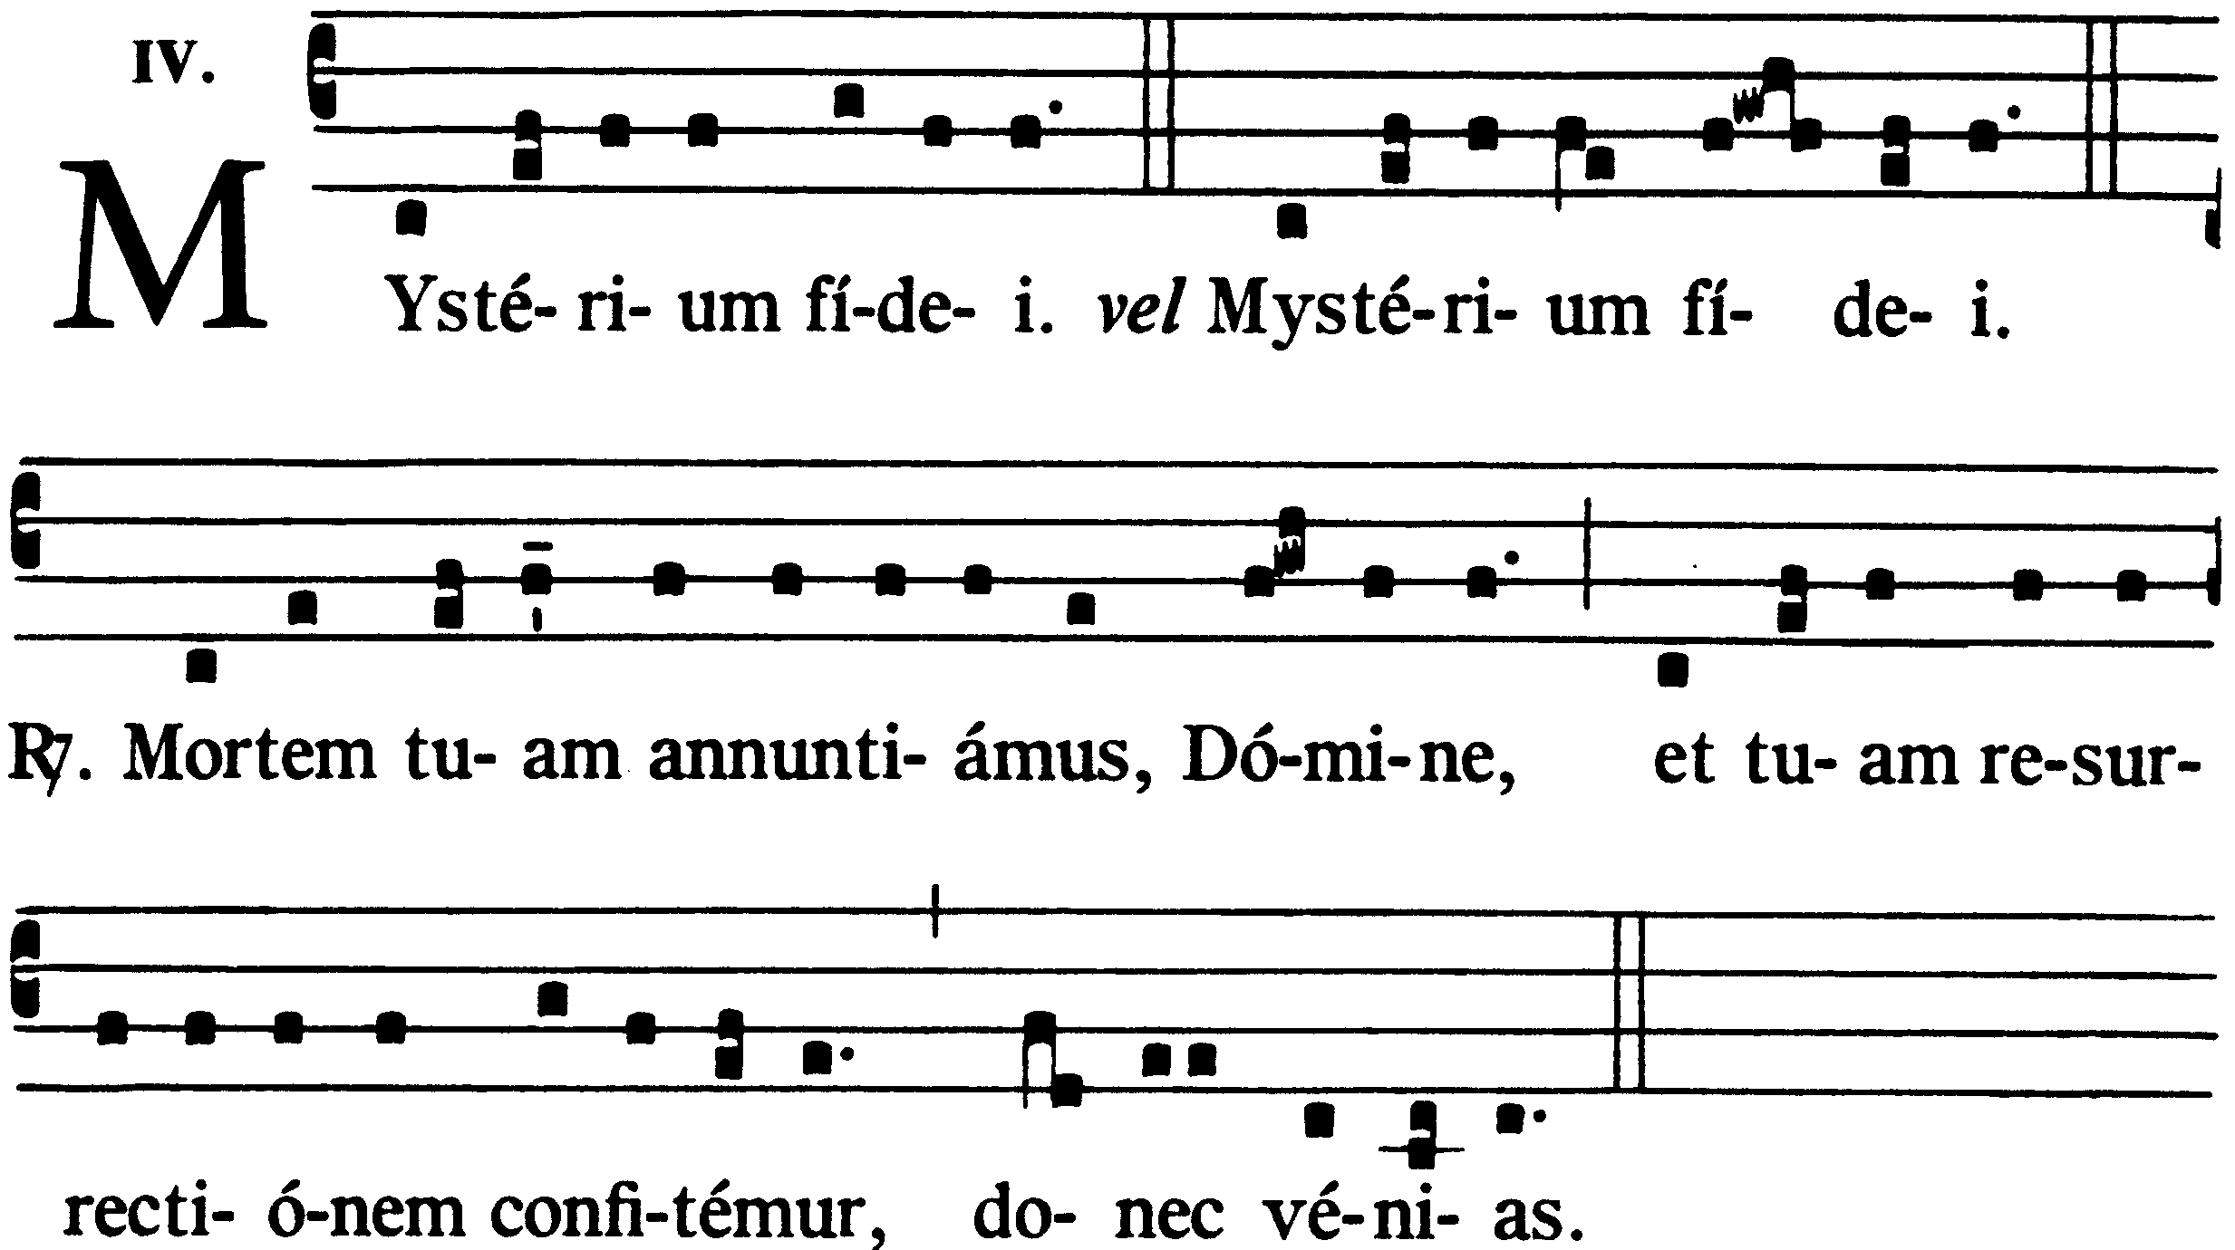 |  |  | Let us proclaim the mystery of faith:  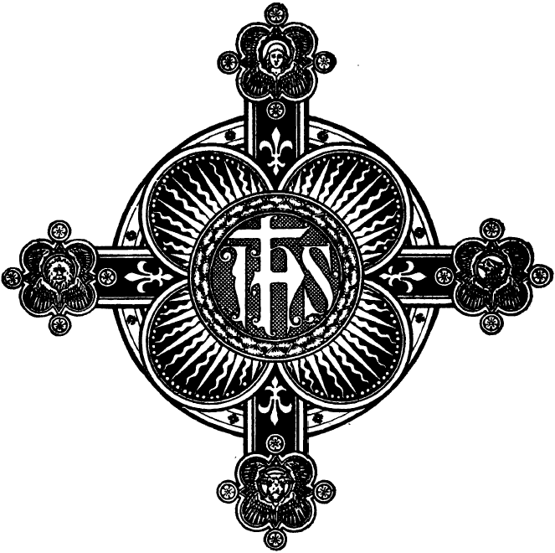  People with celebrant and concelebrants:  Lord, by Your cross and resurrection,  You have set us free,  You are the savior of the world.
Unde et mémores, Dómine, nos servi tui, sed et plebs tua sancta, eiúsdem Christi, Fílii tui, Dómini nostri, tam beátæ passiónis, necnon et ab ínferis resurrectiónis, sed et in cælos gloriósæ ascensiónis: offérimus præcláræ maiestáti tuæ de tuis donis ac datis hóstiam puram, hóstiam sanctam, hóstiam immaculátam, Panem sanctum vitæ ætérnæ et Cálicem salútis perpétuæ.  Supra quæ propítio ac seréno vultu respícere dignéris: et accepta habére, sícuti accépta habére dignátus es múnera púeri tui iusti Abel, et sacrificium Patriárchæ nostri Abrahæ, et quod tibi óbtulit summus sacérdos tuus Melchísedech, sanctum sacrifícium, immaculátam hóstiam.  Súpplices te rogámus, omnípotens Deus: iube hæc perférri per manus sancti Angeli tui in sublíme altáre tuum, in conspéctu divinæ maiestátis tuæ; ut, quotquot ex hac altáris participatióne sacrosánctum Fílii tui Corpus et Sánguinem sumpsérimus,  omni benedictióne cælésti et grátia repleámur.  [ Per Christum Dóminum nostrum. Amen. ] |  |  | Father, we celebrate the memory of Christ, your Son.  We, your people and your ministers, recall his passion, his resurrection from the dead, and his ascension into glory; and from the many gifts you have given us we offer to you, God of glory and majesty, this holy and perfect sacrifice: the bread of life and the cup of eternal salvation.  Look with favor on these offerings and accept them as once you accepted the gifts of your servant Abel, the sacrifice of Abraham, our father in faith, and the bread and wine offered by your priest Melchisedech.  Almighty God, we pray that your angel may take this sacrifice to your altar in heaven; Then, as we receive from this altar the sacred body and blood of your Son, let us be filled with every grace and blessing.  [ Through Christ our Lord. Amen. ]
~ Commemoratio Pro Defunctis ~  Memento étiam, Dómine, famulórum famularúmque tuárum N. et N., qui nos præcessérunt cum signo fidei, et dórmiunt in somno pacis. Ipsis, Dómine, et ómnibus in Christo quiescéntibus, locum refrigérii, lucis et pacis, ut indúlgeas, deprecámur.  [ Per Christum Dóminum nostrum. Amen ]  Nobis quoque peccatóribus fámulis tuis, de rnultitúdine miseratlónum tuárum sperántibus, partem áliquam et societátem donáre dignéris cum tuis sanctis Apostolis et Martyribus: cum Ioánne, Stéphano, Matthía, Bárnaba, [ Ignátio, Alexándro, Marcellíno, Petro, Felicitáte, Perpétua, Agatha, Lúcia, Agnéte, Cæcilia, Anastásia ] et ómnibus Sanctis tuis: intra quorum nos consórtium, non æstimátor mériti, sed véniæ, quǽsumus, largítor admítte.  [ Per Christum Dóminum nostrum. Amen ]  Per quem hæc ómnia, Dómine, semper bona creas, sanctíficas, vivíficas, benedícis, et præstas nobis.  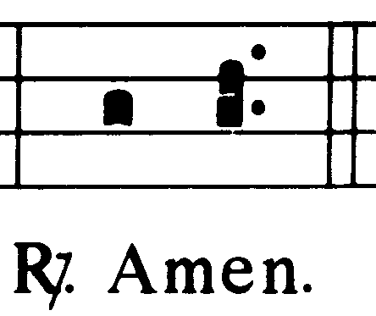  Per ipsum, et cum ipso, et in ipso, est tibi Deo Patri omnipoténti,in unitáte Spiritus Sancti, omnis honor et glória per Omnia sǽcula sæculórum.  Populus acclamat: |  |  | ~ Commemoration of the Dead ~  Remember, Lord, those who have died and have gone before us marked with the sign of faith, especially those for whom we now pray, N. and N. May these, and all who sleep in Christ, find in your presence light, happiness, and peace.  [ Through Christ our Lord. Amen.]  For ourselves, too, we ask some share in the fellowship of your apostles and martyrs, with John the Baptist, Stephen, Matthias, Barnabas, [ Ignatius, Alexander, Marcellinus, Peter, Felicity, Perpetua, Agatha, Lucy, Agnes, Cecilia, Anastasia ] and all the saints. Though we are sinners, we trust in your mercy and love. Do not consider what we truly deserve, but grant us your forgiveness.  [ Through Christ our Lord. Amen]  Through him you give us all these gifts. You fill them with life and goodness, you bless them and make them holy.  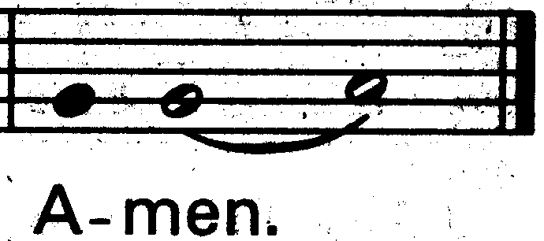  Through him, with him, in him, in the unity of the Holy Spirit, all glory and honor is yours, almighty Father, ever and ever.  The people respond:
~ RITUS COMMUNIONIS ~  Præcéptis, salutáribus móniti, et divina institutióne formáti, audémus dicere:  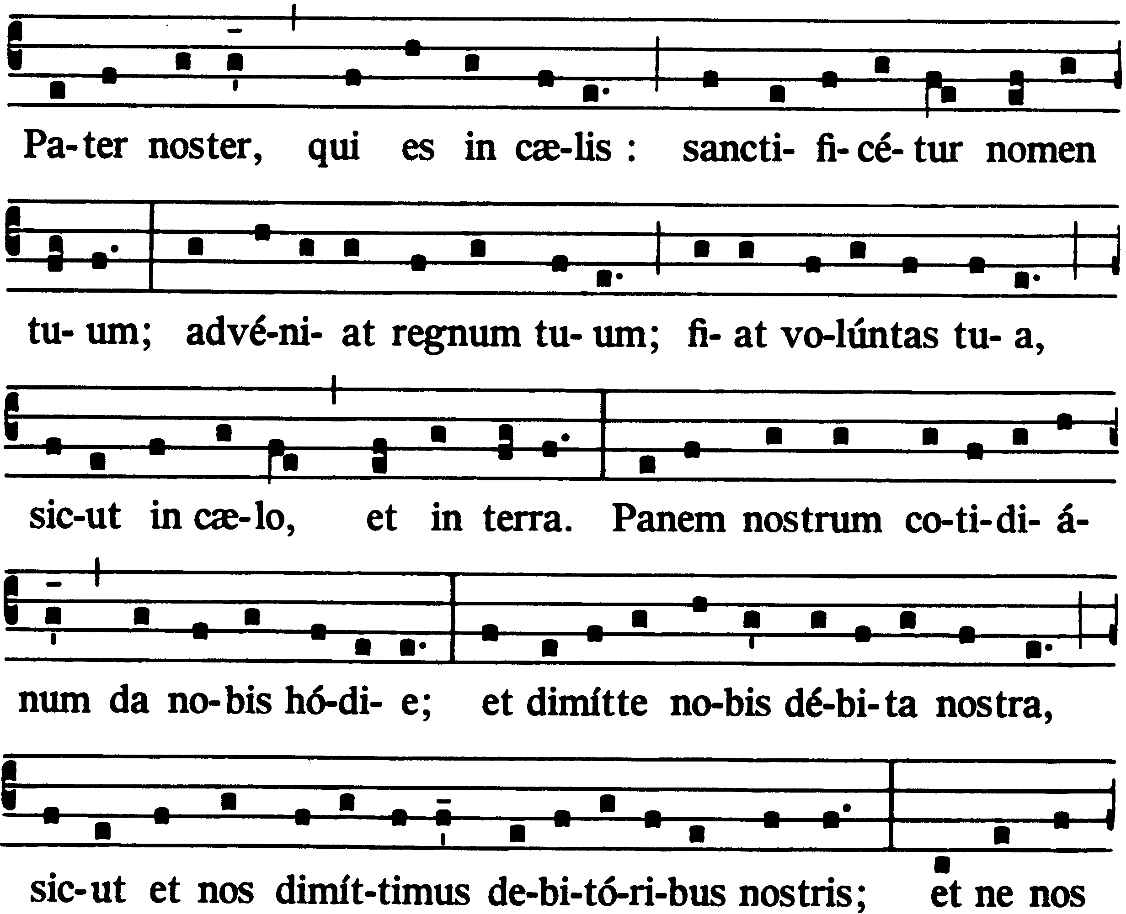  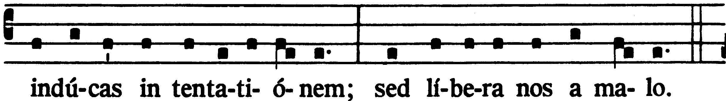  Líbera nos, quǽsumus, Dómine, ab ómnibus malis, da propítius pacem in diébus nostris, ut, ope misericórdiæ tuæ adiúti, et a peccáto simus semper líberi et ab omni perturbatióne secúri: exspectántes beátam spem et advéntum Salvatóris nostri Iesu Christi. |  |  | ~ COMMUNION RITE ~  Let us pray with confidence to the Father in the words our Savior gave us:  Our Father, who art in heaven,  Hallowed be thy name;  Thy kingdom come;  Thy will be done on earth as it is in heaven.  Give us this day our daily bread;  And forgive us our trespasses  As we forgive those who trespass against us;  And lead us not into temptation,  But deliver us from evil.  Deliver us, Lord, from every evil, and grant us peace in our day. In your mercy keep us free from sin and protect us from all anxiety as we wait in joyful hope for the coming of our Savior, Jesus Christ.
~ Doxologia ~  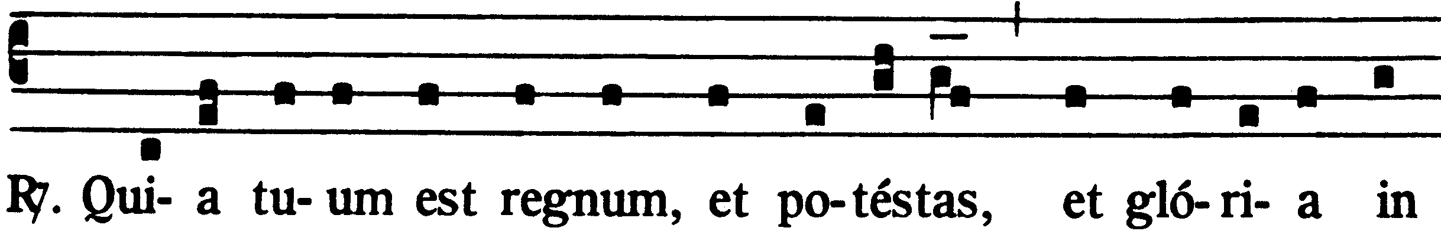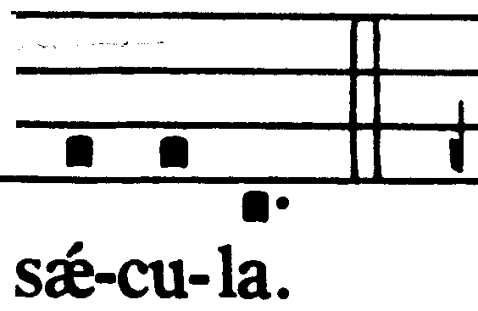 |  |  | ~ Doxology ~  For the kingdom, the power, and the glory are yours, now and for ever.

~ RITUS PACIS ~  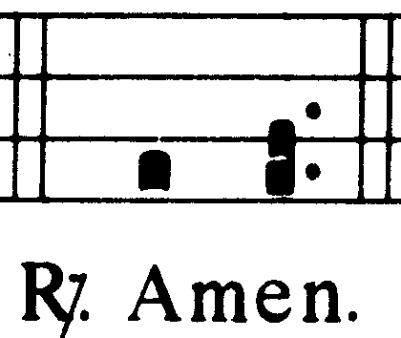  Dómine Iesu Christe, qui dixísti Apóstolis tuis: Pacem relínquo vobis, pacem meam do vobis: ne respícias peccáta nóstra, sed fidem Ecclésæ tuæ; eámque secúndum voluntátem tuam pacificáre et coadunáre dignéris. Qui vivis et regnas in sǽcula sæculorum.  Populus respondet:  Pax Domini sit semper vobiscum.  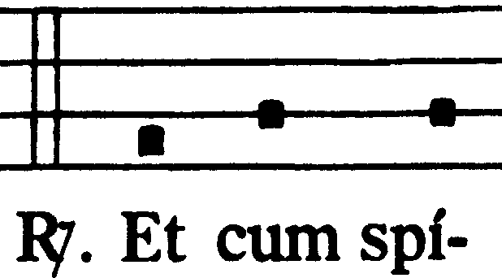  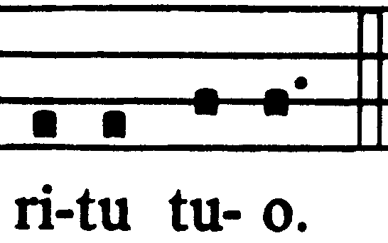  Populus respondet  Offérte vobis pacem. | ~ SIGN OF PEACE ~  Lord Jesus Christ, you said to your apostles: I leave you peace, my peace I give you. Look not on our sins, but on the faith of your Church, and grant us the peace and unity of your kingdom where you live for ever and ever.  The people answer:  The peace of the Lord be with you always.  The people answer: And also with you.  Let us offer each other the sign of peace.
All make a sign of peace, according to local custom. The priest gives the sign of peace to the deacon or the minister.
~ FRACTIO PANIS ~  Hæc commíxtio Córporis et Sánguinis Dómini nostri Iesu Christi fiat accipiéntibus nobis in vitam ætérnam.  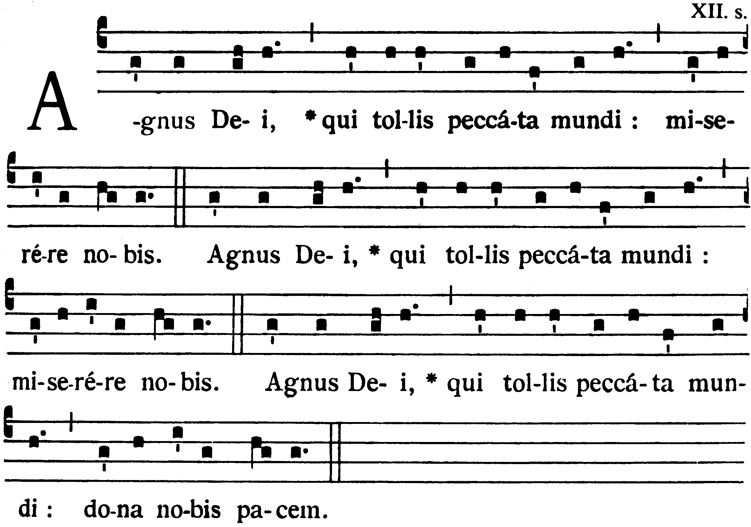 | ~ BREAKING OF THE BREAD ~  May this mingling of the body and blood of our Lord Jesus Christ bring eternal life to us who receive it.  Lamb of God, you take away the sins of the world:  have mercy on us.  Lamb of God, you take away the sins of the world:  have mercy on us.  Lamb of God, you take away the sins of the world:  grant us peace.  

~ PREPARATIO PRIVATA SACERDOTIS ~  Sacerdos diende, manibus iunctis, dicit secreto:  Dómine Iesu Christe, Fili Dei vivi, qui ex voluntáte Patris, cooperánte Spíritu Sancto, per mortem tuam mundum vivificásti: líbera me per hoc sacrosánctum Corpus et Sánguinem tuum ab ómnibus iniquitátibus meis et univérsis malis: et fac me tuis semper inhærére mandátis, et a te numquam separári permíttas.  Vel:  Perceptio Córporis et Sánguinis tui, Dómine Iesu Christe, non mihi provéniat in iudícium et condemnatiónem: sed pro tua pietáte prosit mihi ad tutaméntum mentis et córporis et ad medélam percipiéndam. | ~ PRIVATE PREPARATION OF THE PRIEST ~  Then the priest joins his hands and says inaudibly  Lord Jesus Christ, Son of the living God, by the will of the Father and the work of the Holy Spirit your death brought life to the world. By your holy body and blood free me from all my sins and from every evil. Keep me faithful to your teaching, and never let me be parted from you.  or:  Lord Jesus Christ, with faith in your love and mercy I eat your body and drink your blood. Let it not bring me condemnation, but health in mind and body.

~ COMMUNIO ~  V. Ecce Agnus Dei, ecce qui tollit peccáta mundi. Beáti qui ad cenam Agni vocáti sunt.  R. Dómine, non sum dignus ut intres sub tectum meum: sed tantum dic verbo, et sanábitur ánima mea. | ~ COMMUNION ~  This is the Lamb of God who takes away the sins ‘of the world. Happy are those who are called to his supper.  Lord, I am not worthy to receive you, but only say the word and I shall be healed.
Facing the altar, the priest says quietly:
Corpus Christi custódiat me in vitam ætérnam. | May the body of Christ bring me to everlasting life.
He reverently consumes the body of Christ. Then he takes the chalice and says inaudibly:
Sanguis Christi custódiat me in vitam ætérnam. | May the blood of Christ bring me to everlasting life.
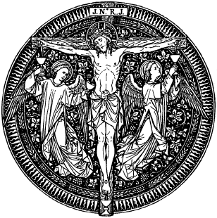
He reverently drinks the blood of Christ.
After this he takes the paten or other vessel and goes to the communicants.

He takes a host for each one raises it a little, and shows it, saying:
Corpus Christi. | The body of Christ.
The communicant answers:
Amen.

~ ANTIPHONA AD COMMUNIONEM ~ | ~ COMMUNION SONG ~
While the priest receives the body of Christ, the communion song is begun.
The vessels arc cleansed by the priest or deacon or acolyte after the communion or after Mass, if possible at the side table.
Meanwhile he says inaudibly:
Quod ore súmpsimus, Dómine, pura mente capiámus, et de múnere temporáli fiat nobis remédium sempitérnum. | Lord, may I receive these gifts in purity of heart. May they bring me healing and strength, now and for ever.
~ SACRUM SILENTIUM ~ | ~ PERIOD OF SILENCE OR SONG OF PRAISE ~
Then the priest may return to the chair. A period of silence may now be observed, or a psalm or song of praise may be sung.
~ ORATIO POST COMMUNIONEM ~ | ~ PRAYER AFTER COMMUNION ~
Then standing at the chair or at the altar, the priest sings or says:
Orémus.  Concede nobis, omnipotens Deus, ut sicut Cena Fílii tui reficimur temporáli, ita satiári mereámur ætérna.  Per Christum.  Amen. | Let us pray. Almighty God, we receive new life from the supper your Son gave us in this world. May we find full contentment in the meal we hope to share in your eternal kingdom. We ask this through Christ our Lord.  Amen.
The Mass concludes with this prayer.

~ TRANSFER OF THE HOLY EUCHARIST ~

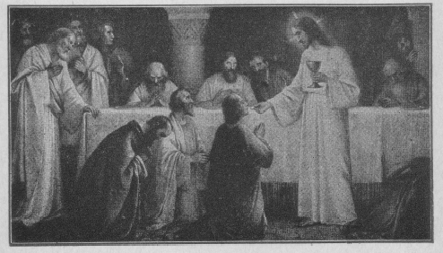
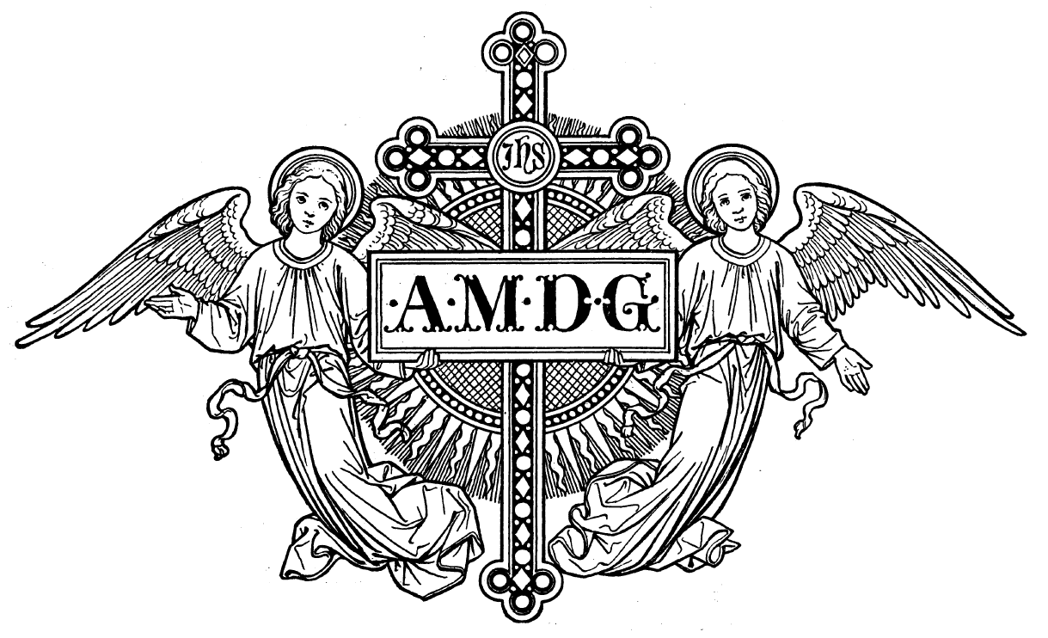
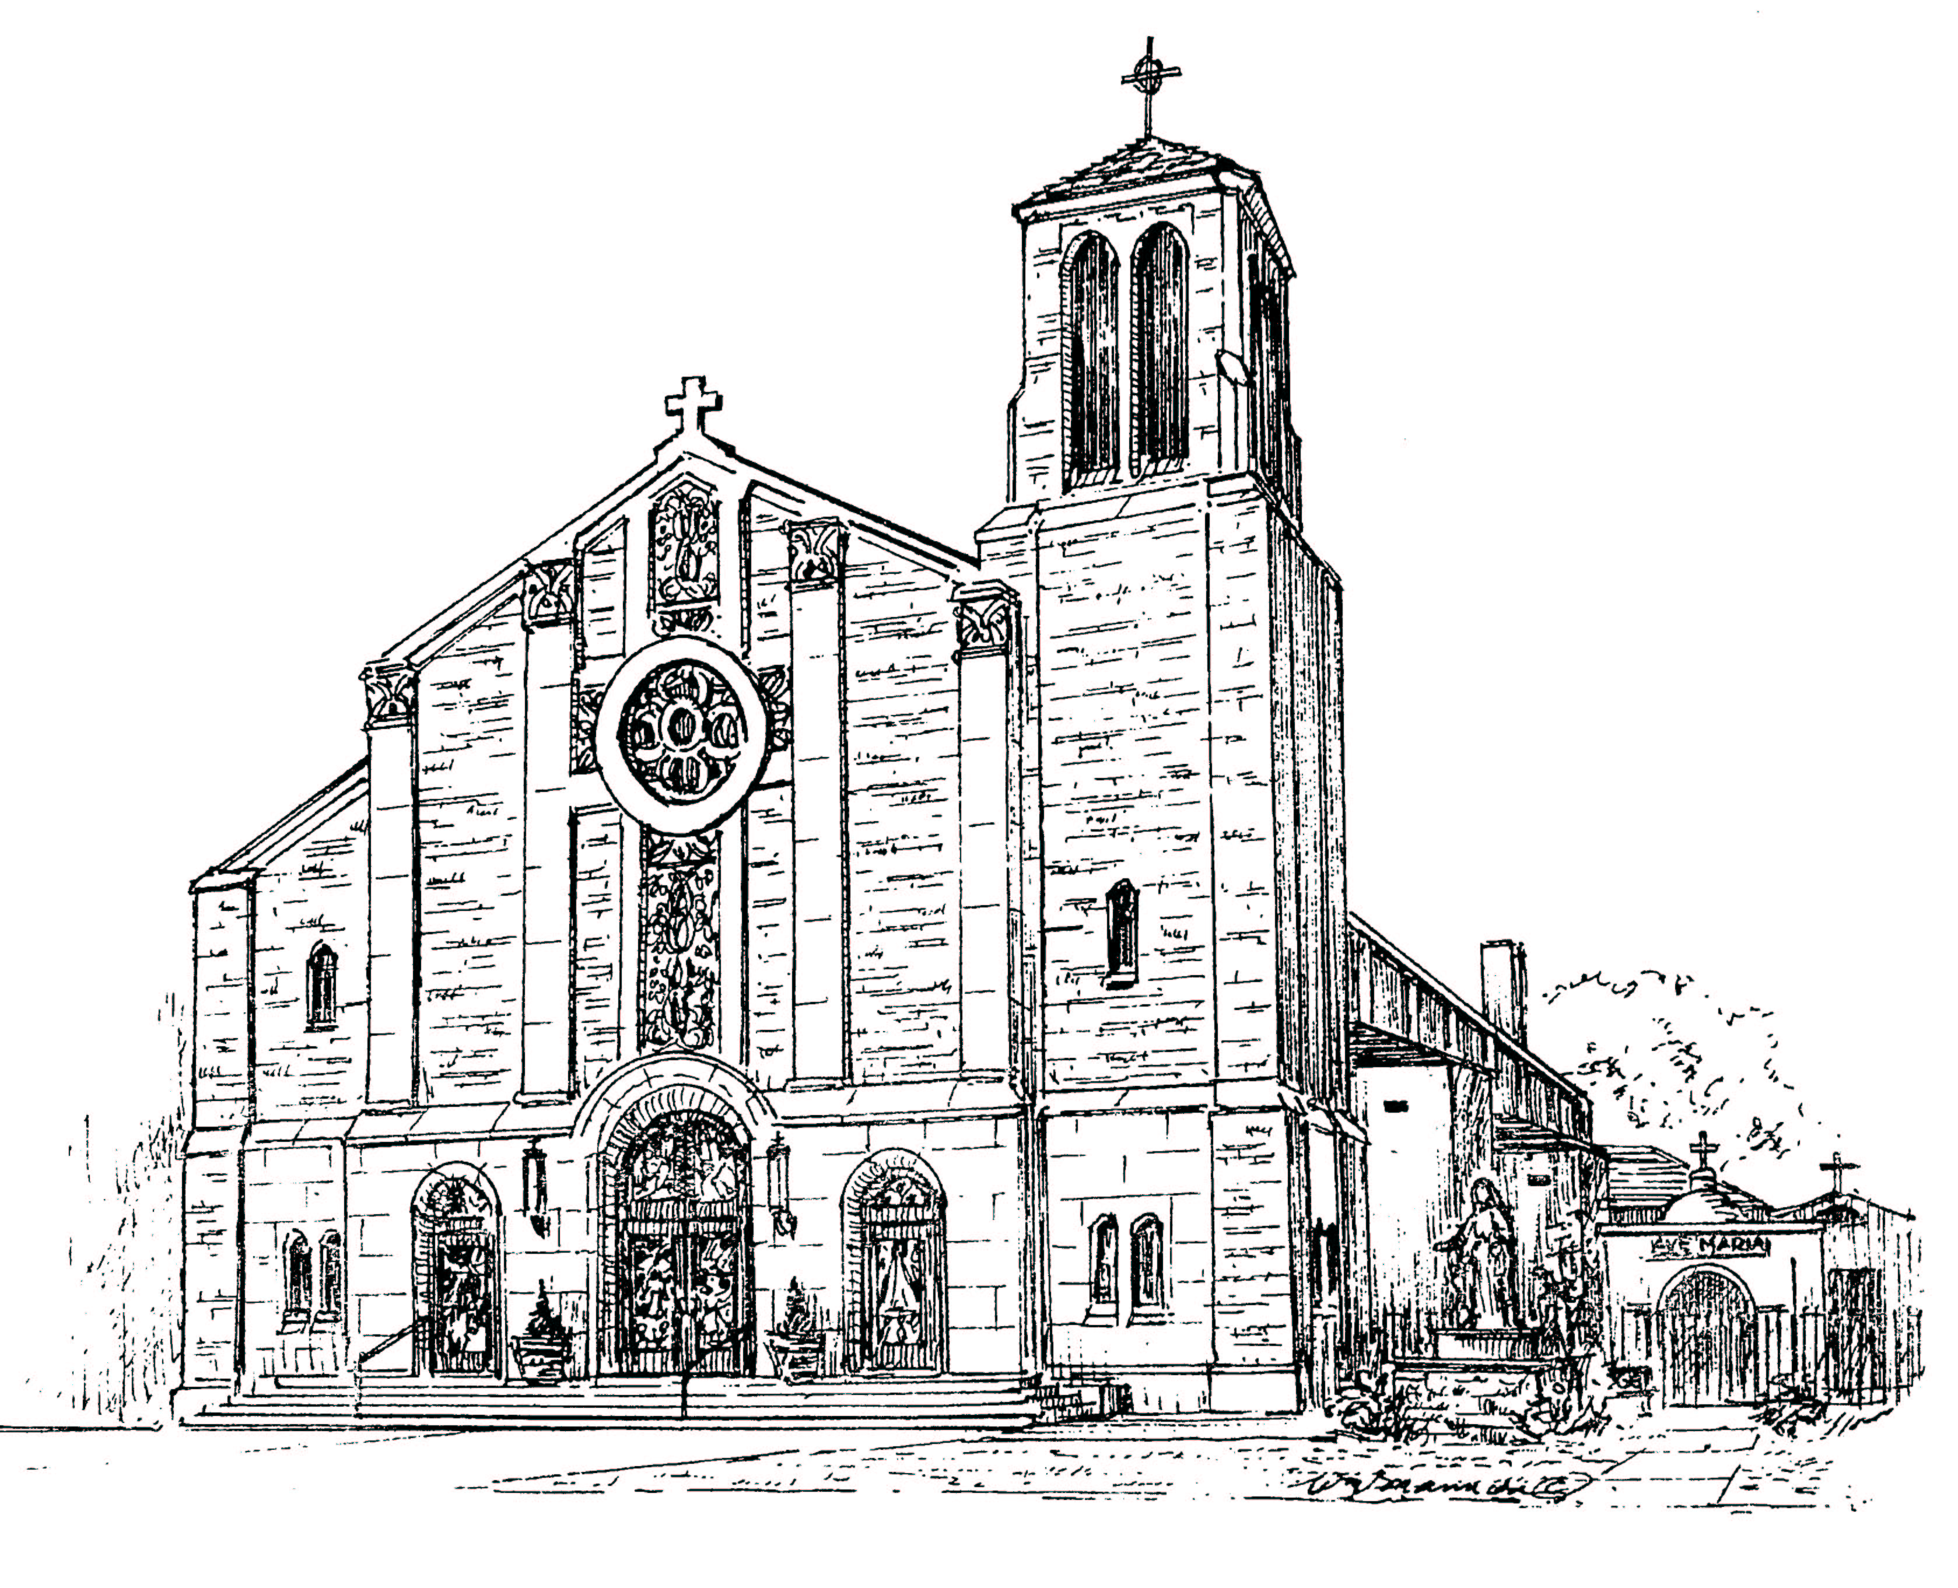
══════════════════════════════════════════════════════

Our Lady of Mount Carmel Church

259 Oliver Street, Newark New Jersey

Rev. Msgr. Joseph F. Ambrosio, Pastor

Rev. Anthony Forte, Parochial Vicar

Rev. Nicholas Figurelli, Weekend Assistant

Rev. Michael Barone, In Residence
Mr. John M. Thomas, Director of Music and Organist
Anno Domini MMXI.

