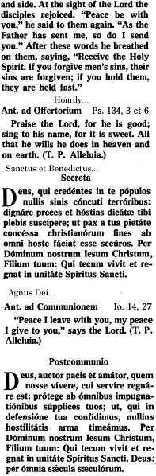 | Mass  For  Peace  In the Extraordinary Form  Missa  Pro  Pace  3:00pm  November 24, 2012  Our Lady  of  Mount Carmel Church  259 Oliver Street  Newark, New Jersey
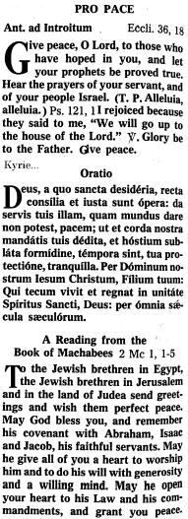 | 