The Feast of Christ The King

Vespers
&
Benediction

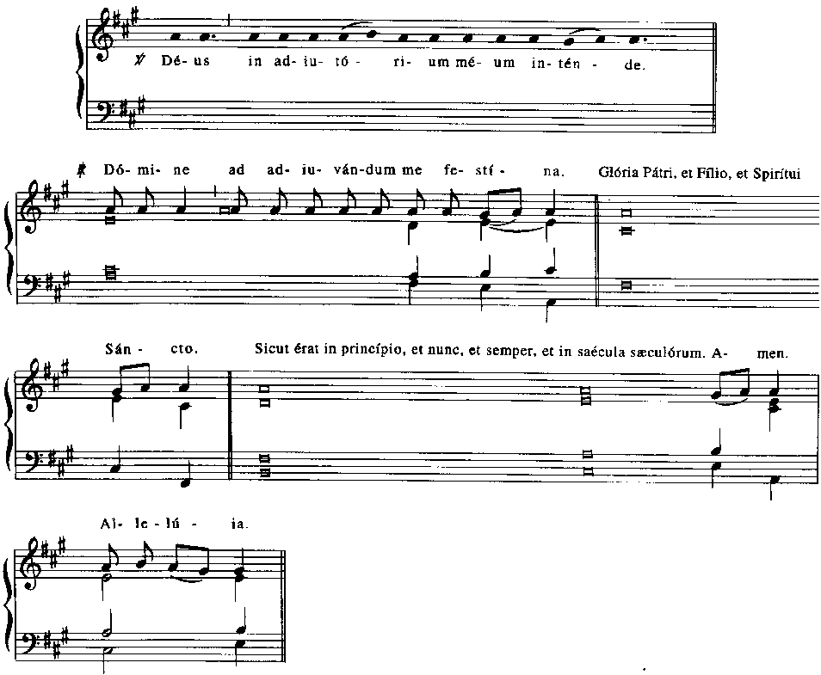
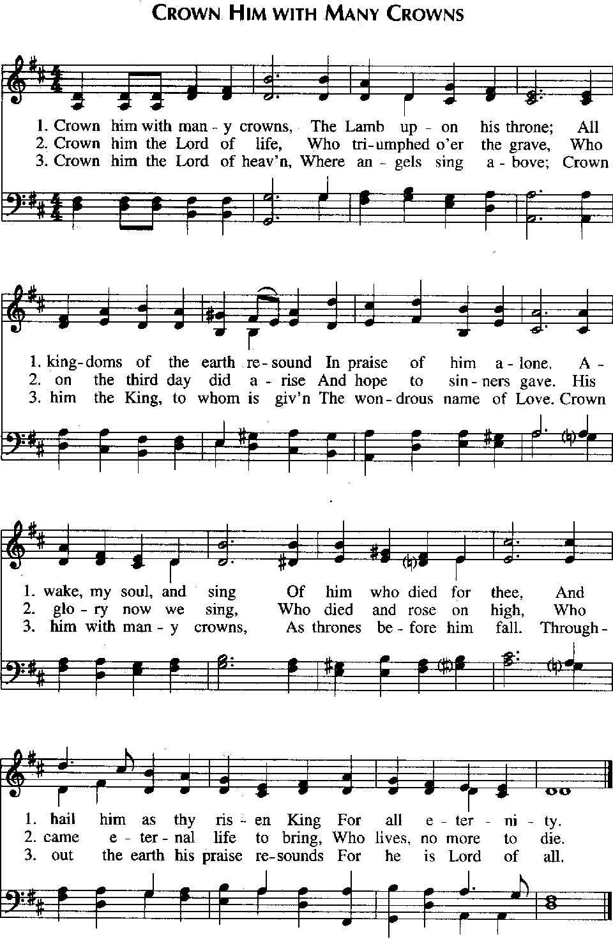
Psalmody:

Psalm 110: 1-5, 7
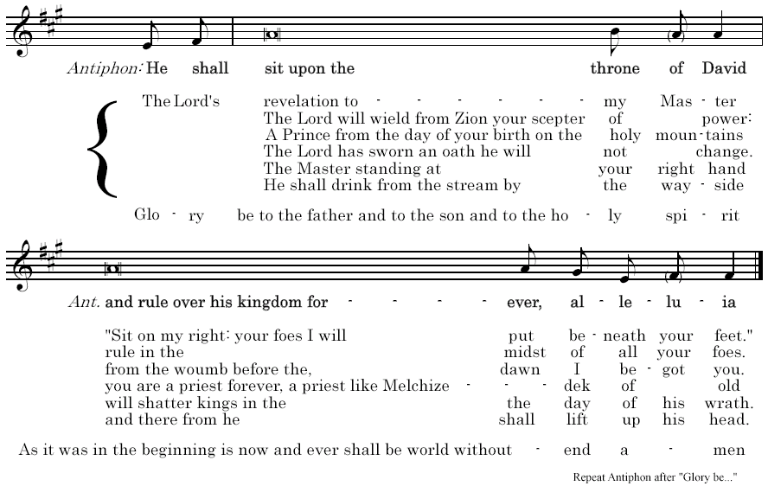
Psalm 145: 1-13
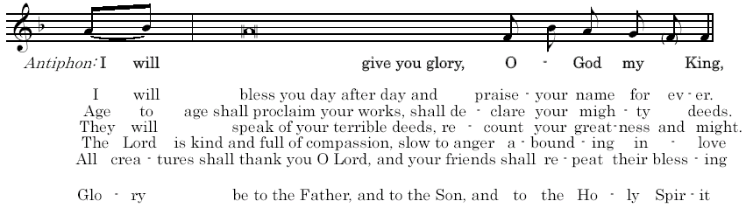
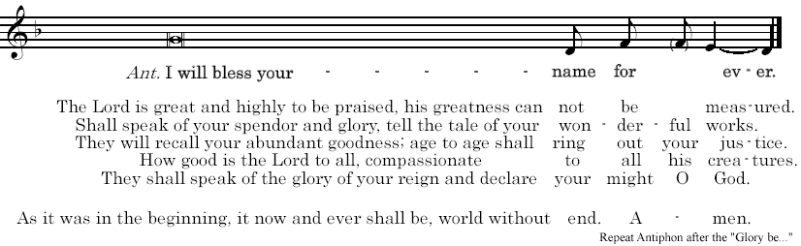
Revelation 19:1-7
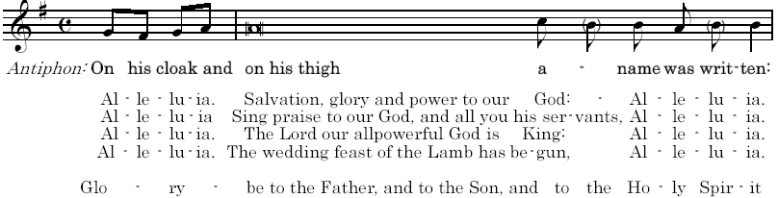
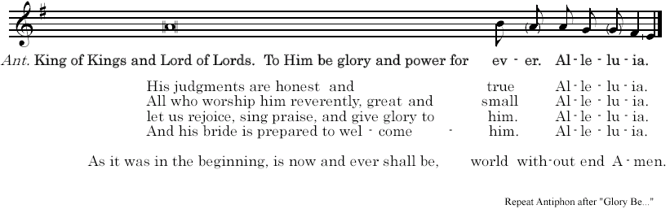

Reading: 1 Corinthians 15:25-28

Christ must reign until God has put all enemies under his feet, and the last enemy to be destroyed is death. Scripture reads that God “has placed all things under his feet.: But when it says that everything has been made subject, it is clear that he who has made everything subject to Christ is excluded. When, finally, all has been subjected to the Son, he will then subject himself to the One who made all things subject to him, so that God may be all in all.

Responsory:

Your throne, O God, shall stand for ever.
- You throne, O God, shall stand for ever.
The scepter of your kingdom is a scepter of justice
- It shall stand for ever.
Glory to the Father...
- Your throne, O God, shall stand for ever.

Homily...


Canticle of Mary:

Antiphon: All authority in heaven and on earth has been given to me,
says the Lord.

Magnificat: anima mea Dominum.  Et exultavit spiritus meus:  in Deo salutari meo.  Quia respexit humilitatem  ancillae suae:  ecce enim ex hoc beatam me dicent  omnes generationes.  Quia fecit mihi magna, qui potens est: et sanctum nomen eius.  Et misericordia eius, a progenie et progenies: timentibus eum.  Fecit potentiam in brachio suo:  dispersit superbos mente cordis sui.  Deposuit potentes de sede:  et exaltavit humiles.  Esurientes implevit bonis:  et divites dimisit inanes.  Suscepit Israel puerum suum:  recordatus misericordiae suae.  Sicut locutus est ad patres nostros:  Abraham, et semini eius in saecula.  Gloria Patri, et Filio,  et Spiritui Sancto,  Sicut erat in principio, et nunc, et semper, et in saecula saeculorum.  Amen. | My soul proclaims the greatness of the Lord, my spirit rejoices  in God my Savior  for he has looked with favor  on his lowly servant.  From this day all generations  will call me blessed:  the Almighty has done great things for  me, and holy is his Name.  He has mercy on those who fear him  in every generation.  He has shown the strength of his arm,  he has scattered the proud  in their conceit.  He has cast down the mighty from their thrones, and has lifted up the lowly.  He has filled the hungry with good things, and the rich he has sent away empty. He has come to the help of his servant Israel for he has remembered his promise of mercy, the promise he made to our fathers, to Abraham and his children for ever.  Glory to the Father, and to the Son, and to the Holy Spirit,  As it was in the beginning, also now, and always, and to ages of ages.  Amen.

Antiphon: All authority in heaven and on earth has been given to me,
says the Lord.

Intercessions:

Let us pray to Christ the King. He is the firstborn of all creation; all things exist in him.
- May your kingdom come, O Lord.
Christ, our king and shepherd, gather your sheep from every land.
- give them pasture in green and fertile meadows.
Christ, our leader and savior, from all men into your own people, heal the sick seek out the lost, guard the strong,
- Call back those who have wandered far away, strengthen those who waver, gather all your sheep into one flock.
Judge of all ages, when you hand over the kingdom to your Father, place us at your right hand,
- So that we may inherit the kingdom prepared for us from the beginning of the world.
Prince of peace, break the weapons of war,
- and inspire the nations with your peace.
Christ, heir of all nations, gather humanity and all the good things of your creation in the kingdom of your Church which your Father bestowed on you,
- so that the whole body of your people, united in the Holy Spirit, may acknowledge you as their head.
Christ, firstborn of the dead and firstfruits of those who have fallen asleep in death,
- bring all who have died to the glory of the resurrection

The Our Father:

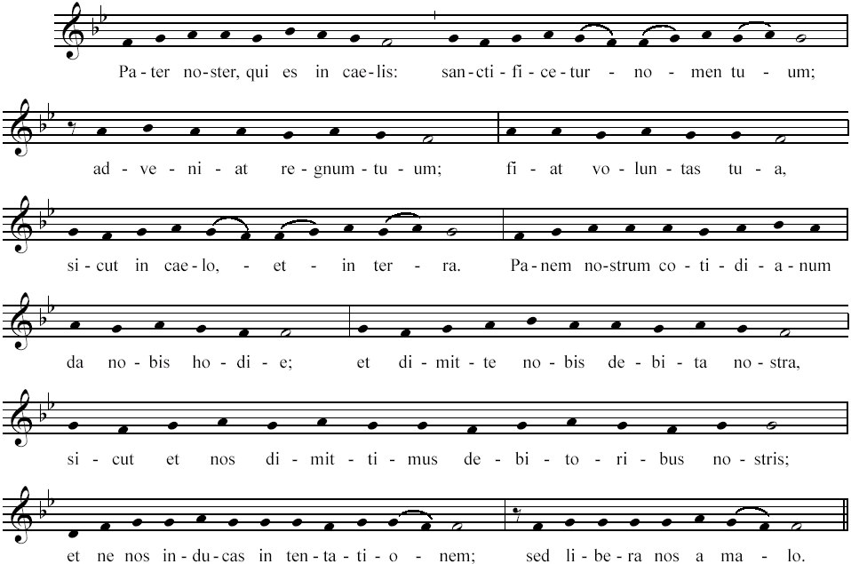

Prayer:

Almighty and merciful God, you break the power of evil and make all things new in your Son Jesus Christ, the King of the universe. May all in heaven and dearth acclaim your glory and never cease to praise you.
We ask this through our Lord Jesus Christ, your Son, who lives and reigns with you and the holy Spirit, one God, for ever and ever.
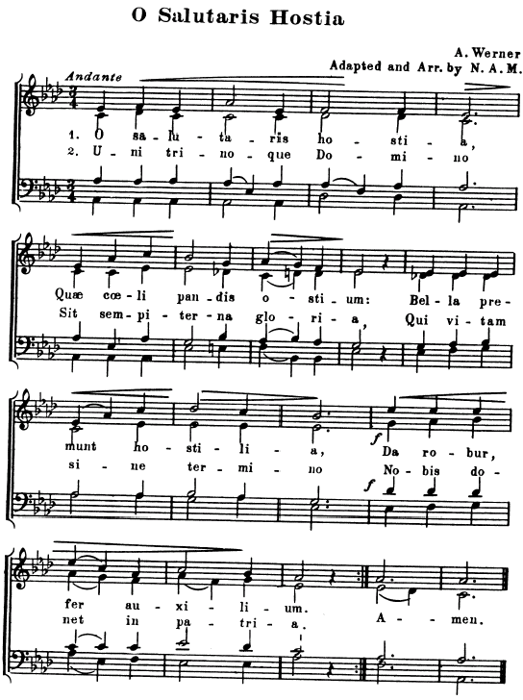
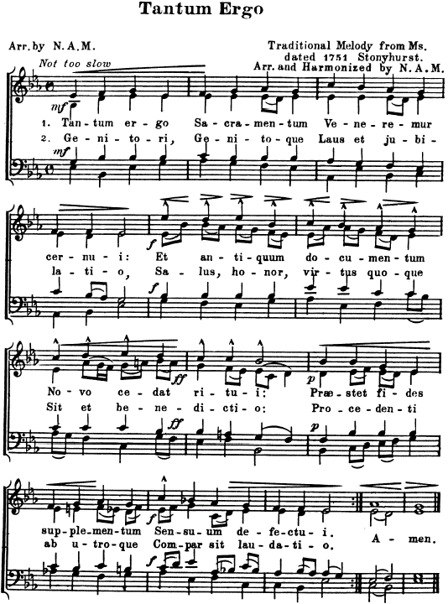

Priest: Panem de Caelo praestitsti Eis. | You have given them  bread from Heaven.

All: Omne delectamentum in se hamentem. | Having all sweetness within it.

Priest: Oremus;  Deus, qui nobis sub Sacramento mirabili Passionis tuae memoriam reliquisti; tribue quaesumus, ita nos Corporis et Sanguinis tui sacra mysteria venerari, ut redemptionis tuae fructum in nobis iugiter sentiamus. Qui vivis et regnas in saecula saeculorum. | Priest: Let us pray:  O God, who under a marvelous Sacrament has left us a memorial of Thy Passion; grant us; we beseech Thee; so to venerate the sacred mysteries of Thy Body and Blood, that we may ever perceive within us the fruit of Thy Redemption. Thou, who livest and reignest forever and ever.
All: Amen.

Divine Praises:
Blessed be God.  Blessed be His Holy Name.  Blessed be Jesus Christ,  true God and true Man.  Blessed be the Name of Jesus.  Blessed be His most Sacred Heart.  Blessed be His most Precious Blood.  Blessed be Jesus in the most Holy  Sacrament of the Altar.  Blessed be the Holy Spirit,  the Paraclete. | Blessed be the great Mother of God,  Mary most Holy.  Blessed be Her Holy and  Immaculate Conception  Blessed be Her glorious Assumption.  Blessed be the name of Mary,  Virgin and Mother.  Blessed be St. Joseph,  Her most chaste spouse.  Blessed be God  in His angels and in His saints.

All: May the heart of Jesus in the most Blessed Sacrament, be Praised, Adored and Loved, with grateful affection, at every moment, in all the Tabernacles of the world, even until the end of time. Amen.
Adoremus in Aeternum! Sanctissimum Sacramentum!

