Chanting the New Translation of the Mass in English
Introductory Rites
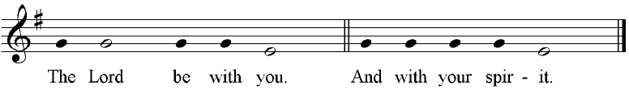
Kyrie
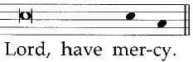
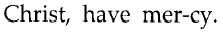
Preface Dialogue
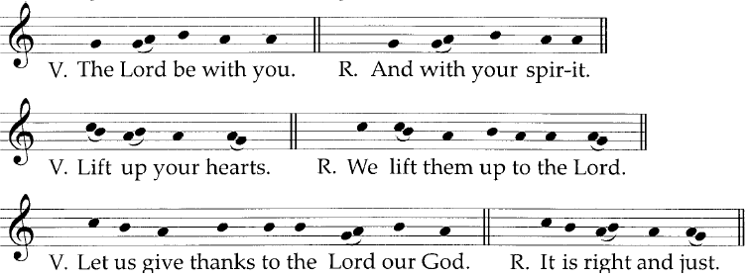
Sanctus
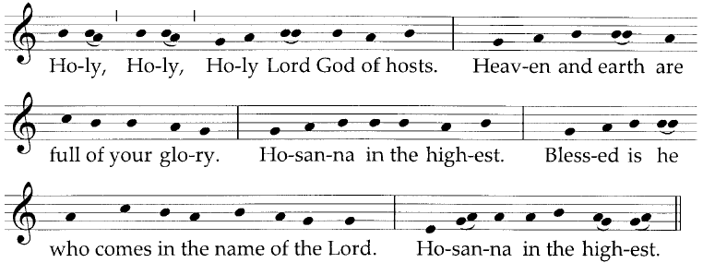
Memorial Acclamation
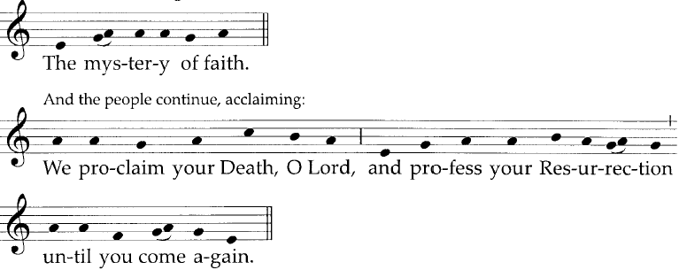
Final doxology of the canon
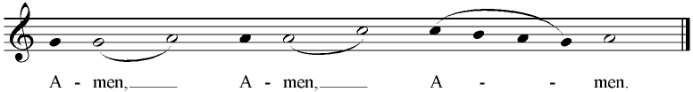
Agnus Dei
